Checklist for Artificial Intelligence in Medical Imaging (CLAIM): Explanation, Elaboration and Examples

Outline
Abstract 3
Introduction 3
How to Use This Document 4
CLAIM 2024 Update Explanation, Elaboration and Examples 4
Item 1 4
Item 2 5
Item 3 6
Item 4 8
Item 5 10
Item 6 10
Item 7 12
Item 8 14
Item 9 15
Item 10 18
Item 11 19
Item 12 21
Item 13 22
Item 14 24
Item 15 25
Item 16 26
Item 17 27
Item 18 29
Item 19 31
Item 20 32
Item 21 33
Item 22 34
Item 23 36
Item 24 36
Item 25 37
Item 26 40
Item 27 41
Item 28 43
Item 29 44
Item 30 45
Item 31 47
Item 32 47
Item 33 49
Item 34 50
Item 35 51
Item 36 53
Item 37 55
Item 38 56
Item 39 58
Item 40 60
Item 41 61
Item 42 63
Item 43 63
Item 44 64
References 65

Checklist for Artificial Intelligence in Medical Imaging (CLAIM): Explanation, Elaboration and Examples

Abstract

Introduction
Artificial intelligence (AI) offers promising applications in disease detection, diagnosis, workflow optimization, and clinical decision-making. The exponential growth of AI research in medical imaging has created unprecedented opportunities for clinical implementation. However, the inherent methodological complexities of AI studies present significant challenges. The literature is replete with inconsistently reported studies that cannot be adequately evaluated by readers and replicated by researchers. . These shortcomings contribute to a proliferation of non-reproducible research, ultimately hindering the reliable clinical translation of AI innovations in imaging (1). To address these challenges, adherence to domain-specific reporting guidelines is essential. Such guidelines ensure that AI research in medical imaging is communicated with the rigor, transparency, and reproducibility required for both scientific integrity and clinical trustworthiness.
The Checklist for Artificial Intelligence in Medical Imaging (CLAIM) was introduced in 2020 to support comprehensive and standardized reporting practices, tailored to the distinctive features of AI studies in imaging (2). Since its release, CLAIM has served as a valuable tool for researchers, peer reviewers, and journal editors—clarifying study objectives, methodology, data sources, and model evaluation. Its impact is evident from the rapid rise in citations, reflecting its broad adoption and influence in the field of medical imaging (3). Recognizing the rapid advancements in AI technologies and the increasing complexity of methodologies since 2020, the CLAIM Steering Committee published an update in 2024 (3). This CLAIM 2024 Update was guided by a structured Delphi consensus process involving 72 experts from diverse backgrounds, including physicians from a variety of medical imaging–related specialties, AI scientists, journal editors, and statisticians (3). The resulting CLAIM 2024 Update refines and expands the original checklist, introduces a "Not Applicable" option for each item to improve flexibility, and clarifies ambiguous terminology. Notably, the term “ground truth” has been replaced with “reference standard,” and the terms “internal testing” and “external testing” are recommended instead of “validation” to mitigate ambiguities. Item 11 of the original checklist has been removed.
This article provides a detailed explanation and elaboration of each item in the CLAIM 2024 Update, supplemented by illustrative examples from the literature that demonstrate appropriate adherence to each item. The objective of this paper is to support researchers and reviewers in the accurate and effective application of the CLAIM guideline. By clarifying the intent and proper implementation of each item, this paper aims to reduce common misinterpretations and encourage effective use of the checklist (4). Enhancing the correct use of CLAIM is intended to improve the overall quality of reporting and, in turn, promote greater transparency, standardization, and reproducibility in AI research within medical imaging and ultimately facilitating its safe and reliable integration into clinical practice.

How to Use This Document
This document explains the CLAIM items in detail; each section includes the item's definition and continues with an explanation and elaboration of the item, accompanied by illustrative examples from the literature showing how each item should be appropriately addressed. Text of the CLAIM guideline is included verbatim by permission of the Radiological Society of North America (RSNA). Incorporation of text from RSNA journals, particularly from Radiology: Artificial Intelligence, is provided with RSNA's permission. Text from other articles is provided under the Creative Commons (CC) license, as noted in the references. For simplicity citations are removed from the original text, and ellipses are used to indicate removals and to ensure all manipulations remain traceable. This rule applies to both CLAIM excerpts and examples.

CLAIM 2024 Guideline: Explanation, Elaboration and Examples

Item 1 — Identification as a study of AI methodology, specifying the category of technology used (e.g., deep learning)

Specify the AI techniques used in the study—such as “vision transformers” or “deep learning”—in the article’s title and/or abstract; use judgment regarding the level of specificity.
Explanation and Elaboration: The specific AI techniques employed in a study should be clearly stated in the title or abstract—preferably both. The level of detail should be carefully balanced according to the journal’s target audience and the state of the art in the field, avoiding unnecessary technical complexity while maintaining sufficient specificity to accurately describe the AI techniques used. Striking this balance ensures accessibility without compromising scientific rigor.
Examples
RadImageNet: An Open Radiologic Deep Learning Research Dataset for Effective Transfer Learning [Title (5), CC-BY 4.0]
To externally validate the performance of three DL algorithms as mammographic screen readers in an independent UK data set. [Abstract (6), CC-BY 4.0]
Textual features were extracted from radiology reports to guide a DL model (ReportGuidedNet) focusing on lesion characteristics. Another DL model (PlainNet) without textual features was developed for comparative analysis. [Abstract (7), CC-BY 4.0]

Item 2 — Summary of study design, methods, results, and conclusions

The abstract should present a succinct structured summary of the study’s design, methods, results, and conclusions. Include relevant details about the study population, such as data source and use of publicly available datasets, number of patients or examinations, number of studies per data source, modalities and relevant series or sequences. Provide information about data partitions and level of data splitting (e.g., patient-or image-level). Clearly state if the study is prospective or retrospective and summarize the statistical analysis that was performed. The reader should clearly understand the primary outcomes and implication of the study’s findings, including relevant clinical impact. Indicate whether the software, data, and/or resulting model are publicly available (including where to find more details, if applicable).
Explanation and Elaboration: A comprehensive abstract that includes all recommended elements facilitates efficient literature searches, enables systematic reviews, and supports evidence-based decision-making. The clear reporting of performance metrics and statistical measures helps readers evaluate the study's significance, while information about resource availability promotes reproducibility and collaborative advancement in the field.

Examples
Results: A total of 26 722 cases (median patient age, 59.0 years [IQR, 54.0-63.0 years]) with mammograms acquired using machines from two vendors were included. Cases included 332 screen-detected, 174 interval, and 254 next-round cancers. Two of three stand-alone DL algorithms achieved noninferior sensitivity (DL-1: 64.8%, P < .001; DL-2: 56.7%, P = .03; DL-3: 58.9%, P < .001) compared with the single first reader (62.8%), and specificity was noninferior for DL-1 (92.8%; P < .001) and DL-2 (96.8%; P < .001) and superior for DL-3 (97.9%; P < .001) compared with the single first reader (96.5%). Combining the DL algorithms with human readers achieved noninferior sensitivity (67.0%, 65.6%, and 65.4% for DL-1, DL-2, and DL-3, respectively; P < .001 for all) compared with double reading (67.4%), and superior specificity (97.4%, 97.6%, and 97.6%; P < .001 for all) compared with double reading (97.1%). [Abstract (6), CC-BY 4.0]
Materials and Methods: In this retrospective study, 26 569 images were collected in 9234 women who underwent digital mammography to pretrain the algorithms. The training data included individuals who had at least 1 year of clinical and imaging history followed by biopsy-based histopathologic diagnosis from March 2013 to November 2018. A model that combined convolutional neural networks with supervised learning algorithms was independently trained to make breast lesion predictions with data from 2120 women in Israel and 1642 women in the United States. Results were reported using the area under the receiver operating characteristic curve (AUC) with the 95% DeLong approach to estimate CIs. Significance was tested with bootstrapping. [Abstract (8), CC-BY 4.0]
Purpose: To train and to validate a deep learning (DL)-based model to produce DSA-like cerebral angiograms directly from dynamic angiograms and then quantitatively and visually evaluate these angiograms for clinical usefulness. [Abstract (9), CC-BY 4.0]

Item 3 — Scientific and/or clinical background, including the intended use and role of the AI approach

The current practice should be explicitly mentioned. Describe the study’s rationale, goals, and anticipated impact. Present a focused summary of the pertinent literature to describe current practice and highlight how the investigation changes or builds on that work. Guide readers to understand the underlying science, assumptions underlying the methodology, and nuances of the study.
Explanation and Elaboration: The introduction should contextualize the work presented in the sections that follow in terms of the significance of the problem or area of inquiry, as well as prior investigations and current state of the art. Understanding the intended use and role of the AI enables the reader to evaluate the reported performance of the AI in an appropriate context, as minimum thresholds for performance vary widely by use case. Description of gaps or limitations in existing knowledge, technology or practice addressed by the manuscript elucidate the advances that have been achieved.

Examples
However, differences in MRI acquisition protocols and scanners affect consistency and reproducibility of brain volumetry … and are a major impediment for the clinical translation of automated tools. To tackle this problem, many data harmonization tools have emerged in recent years…. Such algorithms can either harmonize original scans (eg, DeepHarmony) … or derivatives extracted from the scans (eg, ComBat) ... Some of these algorithms have been shown to harmonize patient data affected by a neurodegenerative disease … while preserving disease-related signature. However, such harmonization techniques typically work only for the scanner models they have been trained on, and, in some instances require the same individuals to be scanned with different scanners…. Harmonizing volumetric data from MRI scanners not encountered during initial model training requires additional training with a substantial number of images from these scanners…. This poses a challenge for the deployment of such models for clinical use. [Introduction (10), CC-BY 4.0]
Despite recent advances in the automatic processing of spinal cord MRI…, robust methods for detecting quantitative MRI biomarkers in SCI are lacking. As a result, most studies involve manual identification of these biomarkers…. This task is time-consuming and further hampered by interrater variability, making it impractical in clinical trials…. Furthermore, segmentation of intramedullary SCI lesions on MRI scans poses an extremely challenging task mainly due to the evolving appearance of lesions in different injury phases (eg, acute, subacute, intermediate)…. Surgical implants in postoperative MRI scans might also cause severe image artifacts. Deep learning (DL) can improve diagnosis and prognostication in SCI by automating the lesion annotation process, thereby reducing rater-specific biases and facilitating the analysis of large SCI cohorts across sites…. Indeed, quantitative SCI lesion biomarkers derived from DL-based automatic segmentations have been shown to correlate well with clinical measures of motor impairment…. Despite its numerous potential advantages, DL has not been sufficiently explored in the context of SCI, with no open-source methods existing to date. This gap suggests the need for an automatic biomarker identification method that takes into account the complex pathophysiology of patients with SCI…, generalizes to multiple sites, and remains easily accessible by researchers. [Introduction (11), CC-BY 4.0]
Radiology reports are meticulously crafted and reflect the train of thought and reasoning of radiology experts during interpretation of medical images; they provide detailed descriptions of brain lesions characteristics and anatomic alterations in extensive real-world clinical cases and are organized in a standardized manner. Radiology reports are naturally and seamlessly generated during the clinical diagnostic process, incurring no supplementary production costs. Consequently, they can serve as a high-accuracy, low-cost source of weak annotations for MR images. Previous studies … have accomplished multimodal image-text pretraining through the application of contrastive learning on chest radiographs and corresponding radiology reports. This involved the use of vision and text encoders or pretrained models customized for radiology-specific contexts. In contrast to radiographs, MR images are characterized by multiple sequences, which offer better tissue contrast and can help discern lesions with complex components, leading to more intricate and rich textual features in their reports. An effective diagnostic aid model should provide accurate and stable diagnostic results, offering interpretable indicators to substantiate its predictions as references for radiologists. To achieve this in a cost-effective manner, we propose an approach that uses data derived from radiology reports to enhance the attention of a DL model toward lesion characteristics. The current study aimed to facilitate lesion detection at brain MRI using this approach, while generating interpretable attention maps without the need for manual image segmentation during model training. [Introduction (7), CC-BY 4.0]

Item 4 — Study aims, objectives, and hypotheses

Define clearly the clinical or scientific question to be answered; avoid vague statements or descriptions of a process. Limit the chance of post hoc data dredging by specifying the study’s hypothesis a priori. The study’s hypothesis and objectives should guide appropriate statistical analyses, sample size calculations, and whether the hypothesis will be supported or not.
Explanation and Elaboration: The effectiveness and usefulness of an AI should be evaluated in the context of the specific problem it is intended to solve. In the absence of clear statement of the problem, it is difficult to determine the importance and impact of the work. The objectives and hypotheses (if not a data-driven approach) provide context for the reader to evaluate whether the methods and tests employed in the investigation are appropriate for achieving the stated aims of the work.

Examples
The current study is motivated to investigate this critical screening task because clinicians often wonder whether existing public datasets, such as NLST, are sufficient to train effective AI models or if newer datasets, such as the NELSON study, are necessary to be pixel-annotated to further improve performance. Similarly, AI developers need insights into whether collecting more NLST-like data will significantly enhance their models or if diminishing returns set in. Although larger datasets and deeper neural networks generally lead to improved performance, the prediction of nodule malignancy risk may encounter inherent limitations. These limitations may arise from the nature of the morphologic biomarkers themselves, suggesting that there could be a maximum level of predictive accuracy that cannot be surpassed, regardless of the volume of data or the complexity of the model.
This article investigates the relationship between the volume of training data and the performance of an AI model designed for pulmonary nodule malignancy risk assessment. Specifically, we investigated whether increasing the size of the AI training dataset leads to continuous performance improvements on the external dataset, or if the performance eventually plateaus, indicating a limit to the benefits of adding similar data. [Introduction (12), © RSNA, 2025]
However, CT-derived morphologic measurements can be difficult to interpret. Reference charts have long underpinned clinical decision-making; pediatric growth charts, for example, offer indispensable benchmarks for monitoring development ... In neuroimaging, analogous MRI-based approaches have emerged …, such as the creation of brain charts … that can standardize age-related structural changes and support early detection of neuropsychiatric conditions. However, equivalent reference standards for the rest of the body remain largely absent, although the standardized assessment of anatomy in CT imaging lends itself well to anatomic benchmarking. Large-scale efforts such as the UK Biobank have built extensive MRI repositories …, but no comparable CT-based cohorts exist. Hospital picture archiving and communication systems (PACS) represent a rich yet underutilized data repository that holds substantial promise for quantifying anatomic variability. Using these data could enable the establishment of comprehensive, data-driven reference models of human anatomy based on CT imaging.
In this study, we generate comprehensive body charts for 104 anatomic structures across adulthood from more than 200 000 CT scans and over 7.8 million segmented anatomic structures. Our primary aim is to characterize the nonlinear, age-dependent trajectories of organ volumes and to establish reference models that convert raw measurements into age- and sex-standardized centile scores. To achieve this, we identify optimal parametric forms of fractional polynomials (FPs) that capture complex aging patterns in both median and variance, going beyond traditional linear models. [Introduction (13), © RSNA, 2026]

Item 5 — Prospective or retrospective study

Indicate if the study is prospective or retrospective. Evaluate AI models in a prospective setting, if possible.
Explanation and Elaboration: Prospective evaluation is preferred because it evaluates the model in a setting more similar to the expected clinical use of the model. Retrospective evaluation is usually faster and less expensive, but more likely to be subject to confounding and bias. In complex multimodal clinical datasets it is often difficult to establish what data would have been available at the time the model would have run – for example a single note or report may include data obtained both before and after an imaging study was performed. Where it is not feasible to perform prospective evaluation, there should generally be discussion of potential biases and confounders due to retrospective evaluation in the discussion section.
Examples
This retrospective study was classified as nonhuman subjects research by the institutional review board of the University of Arkansas for Medical Sciences (UAMS) (under institutional review board approval no. 262472), and formal review was waived. Three retrospective datasets were used to develop and test the proposed model: a local dataset to train and test models and two external datasets to further assess performance. [Material and Methods (14), CC-BY 4.0]
We prospectively recruited patients referred for clinical CMR exam for myocardial scar evaluation. Patients were approached before the CMR exam for willingness to allow additional research scanning at the end of their clinical exam, which added < 5 min to their clinical exam. [Material and Methods (15), CC-BY 4.0]

Item 6 — Study goal

Describe the study’s design and goals, such as model creation, exploratory study, feasibility study, or noninferiority trial. For classification systems, state the intended use, such as risk assessment, triage, diagnosis, screening, staging, monitoring, surveillance, prediction, or prognosis. Describe the type of predictive modeling to be performed, the target of predictions, and how it will solve the clinical or scientific question.
Explanation and Elaboration: The study design and goal is the bridge between the broader context of the study and its specific execution, ensuring clarity about what the research seeks to achieve and how the research will help accomplish the stated problem. For example, a classification model for triaging chest X-rays requires different design and testing considerations than a segmentation model for delineating tumors. A well-defined study design ensures transparency, guides appropriate methodological decisions, and establishes the criteria against which the research’s success will be evaluated.

Examples
A prospective real-life clinical trial was conducted to assess the diagnostic performance of the smartphone app Dermalyser® (AI Medical Technology, Stockholm, Sweden), an AI-based decision support tool (henceforth ‘the app’) to detect melanoma. The study was performed in accordance with the STARD 2015 guidelines for diagnostic accuracy studies and approved by the Swedish Medical Products Agency and the Swedish Ethical Review Authority. The trial was registered with ClinicalTrials.gov (NCT05172232). The machine learning algorithm behind the decision support had been trained in silico prior to the start of the study on an extensive number of dermoscopic images of skin lesions, showing an area under the receiver operating characteristics (ROC) curve (AUROC) of 0.94. The algorithm was fixed prior to the start of data collection (i.e. no further training or modification of its performance was done during the study). When applied on a dermoscopic image, the algorithm produces a value between 0 and 1, corresponding to a calculated probability (or risk) of the lesion being a melanoma, but in its communication with the user, the intention of the decision support is to be presented as a dichotomous outcome (‘evidence of melanoma detected’ or ‘no evidence of melanoma detected’) based on this probability. Thus, prior to data inclusion we decided on a cutoff level for the dichotomy that would entail a reasonable risk of false negatives without leading to an extensive proportion of false positives, which from the ROC curve in the aforementioned in silico pretrial corresponded to a sensitivity and specificity of 95% and 78%, respectively. [Material and Methods (16), CC-BY 4.0]
This study is a prognostic accuracy cohort study utilizing prospectively collected multicenter hospital-based stroke registries. The objective of this study is to develop, validate, and interpret a machine learning system for predicting 3-month functional outcomes after stroke. We utilized a derivation dataset for model training and internal validation, while external datasets were used for external validation. [Material and Methods (17), CC-BY 4.0]
This retrospective study utilized deep convolutional neural network models to assess endodontic case difficulty from periapical radiographs based on AAE guidelines. In our research paper, we examined five pre-trained and state-of-the-art convolutional neural network (CNN) architectures, namely ResNet50, ResNet18, Inception V2, VGG16 (with batch normalization layers), and ResNext50. Additionally, we explored four self-supervised learning (SSL) approaches, namely SimCLR, MoCo, BYOL, and DINO. All models were employed to categorize endodontic case difficulty for binary classification analysis. Additionally, the top performing model was leveraged to predict overall difficulty scores through regression. The Ethics Committee of the Hamadan University of Medical Sciences approved this study (IR.UMSHA.REC.1402.026). The study results were reported in accordance with the Checklist of Artificial intelligence in Medical imaging.…. [Material and Methods (18), CC-BY 4.0]

Item 7 — Data sources

State the source(s) of data, including publicly available datasets and/or synthetic images; provide links to data sources and/or images, if available. Describe how well the data aligns with the intended use and the model’s target population. … Authors are strongly encouraged to deposit data and/or software used for modeling or data analysis in a publicly accessible repository.
Explanation and Elaboration: Any intelligence in a machine learning model is derived from the training data, so the source of the data is of paramount importance. Publicly available data is strongly preferred as it enables other investigators to build on the work in the manuscript and make direct comparisons of performance. Often the population represented in the dataset differs from the target population due to data availability. For instance, a model intended to determine whether a lesion should be biopsied might be trained on a dataset consisting of paired images and biopsy results would be applied to a population of all patients with lesions, but trained only on patients whose lesions were biopsied. Any such discrepancies should be highlighted and their implications discussed.

Examples
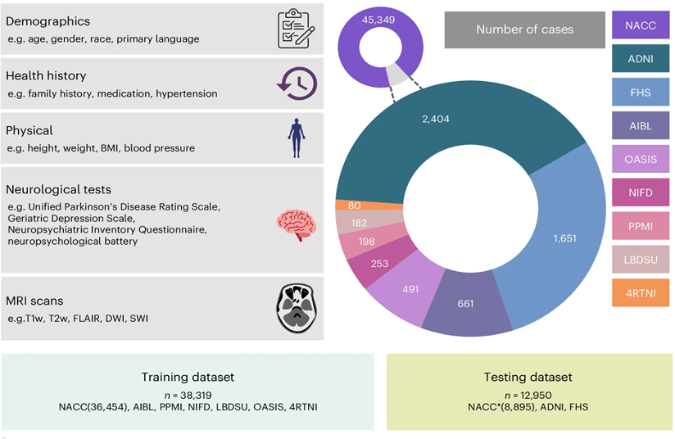
Fig. 1 | Data, model architecture and modeling strategy. a, Our model for differential dementia diagnosis was developed using diverse data modalities, including individual-level demographics, health history, neurological testing, physical/neurological exams and multisequence MRI scans. These data sources whenever available were aggregated from nine independent cohorts: 4RTNI, ADNI, AIBL, FHS, LBDSU, NACC, NIFD, OASIS and PPMI…. For model training, we merged data from NACC, AIBL, PPMI, NIFD, LBDSU, OASIS and 4RTNI. We used a subset of the NACC dataset for internal testing. For external validation, we utilized the ADNI and FHS cohorts. [Figure 1a and its caption (19), CC-BY 4.0]
The BIDMC cohort. The BIDMC cohort is a dataset comprised of routinely collected data from Beth Israel Deaconess Medical Center, Boston, USA. Subjects over 16 years old with a valid ECG performed from 2014 to 2023 were included. Prior ECGs back to 2000 were included for these subjects. Mortality was determined via the Massachusetts Department of Public Health (DPH) and/or review of the BIDMC electronic medical record, while diagnostic International Classification of Diseases (ICD) codes were used to determine disease status. Subjects were censored at time of death or last in person hospital contact. [Supplementary appendix (20), CC-BY 4.0]

Item 8 — Inclusion and exclusion criteria

Specify inclusion and exclusion criteria, such as location, dates, patient-care setting, demographics (e.g., age, sex, race), pertinent follow-up, and results from prior tests. Define how, where, and when potentially eligible participants or studies were identified. Indicate whether a consecutive, random, or convenience series was selected.
Explanation and Elaboration: Understanding the composition of a dataset is key to evaluating the validity and transferability of machine learning models based on the dataset. In addition to explicit inclusion and exclusion criteria, which have obvious impact on dataset composition, any sampling procedure must be described as this can influence the composition. Sampling methods other than consecutive or fully randomized samples often introduce biases into a dataset.

Examples
The inclusion criteria were as follows: (a) imaging performed using a 3-T MRI system and (b) MRI fusion US-guided targeted biopsies were performed for MRI-suspicious lesions, followed by systematic biopsies. We excluded 262 patients from the analysis because of lack of biopsy results; 65 patients because of a longer than 2-week interval between screening and pathology; 551 patients because of a history of previous treatment for csPCa, such as antihormonal therapy, radiation therapy, focal therapy, cryotherapy, or surgery before MRI; 108 patients because of duplicate cases; and 76 patients because of incomplete sequences. Data from 2203 consecutive patients from Cs 1–3 were finally used as external testing set 1 to evaluate the performance of the DL model in a real clinical setting. Among these 2203 patients, 29.6% (652 of 2203) had rectal artifacts with varying severity (232, 222, and 198 patients had mild, moderate, and severe artifacts, respectively). Patients without visible artifacts (1551 of 2203) formed external testing set 2. To assess the impact of RAN interference on the DL model, subtle, invisible rectal artifact–like noises were intentionally introduced into external testing set 2 (referred to as external testing set 2*) to conduct a rectal artifact–pattern adversarial noise attack experiment. [Materials and methods, “patients” section (21), CC-BY 4.0]
The study was designed as a multicenter study of detection accuracy and feasibility on a retrospective cohort including all screening mammograms in the Region of Southern Denmark between August 4, 2014, and August 15, 2018, as previously reported…. In brief, a study population of 272008 consecutive screening mammograms was retrieved, including original binary assessments of normal or abnormal (recall) by breast radiologists through independent, blinded double reading with arbitration for disagreements. Exclusion criteria were insufficient image quality, missing images, lack of follow-up, or image data types not supported by the AI. [Materials and methods “Study Design and Sample” section (22), CC-BY 4.0]
Mammography and pathology data records for 915,334 screening and diagnostic examinations from 94,656 patients were obtained from a single site at US Dataset 1, acquired from 2008 to 2017. From this dataset, digital breast tomosynthesis (DBT) examinations and those in patients with breast implants were removed. This process resulted in a total of 117,844 screening examinations from 38,456 patients with a mean age of 57.4 years (standard deviation 10.2). The examinations were acquired on two scanner models: Hologic Selenia (HSE) (39,710 examinations, 33.7%) and Hologic Selenia Dimensions (SED) (78,134 examinations, 66.3%). The examinations were interpreted by one of 11 radiologists with subspecialties in breast imaging and experience ranging from 2 to 30 years. Among the examinations, 979 (0.8%) were cancer-positive confirmed by biopsy, 78 (0.07%) were interval cancers, and 1,638 (1.4%) were benign confirmed by biopsy. In addition to the screening examinations, 25,749 diagnostic examinations available from the same data source were utilized to augment training. These diagnostic examinations were gathered such that all images had image-level annotations localizing any findings provided retrospectively by a radiologist with breast imaging subspecialty and magnification factors no larger than 1.1, therefore removing the magnified views. These diagnostic examinations added 2,555 examinations that were cancer positive confirmed by biopsy. [Appendix S1, Data Acquisition and Labeling section (23), CC-BY 4.0]

Item 9 — Data pre-processing

Describe preprocessing steps to allow other investigators to reproduce them. Specify the use of normalization, resampling of image size, change in bit depth, and/or adjustment of window/level settings. If applicable, state whether the data have been rescaled, threshold-limited (“binarized”), and/or standardized. Specify processes used to address regional formatting, manual input, inconsistent data, missing data, incorrect data type, file manipulations, and missing anonymization. State any criteria used to remove outliers…. When applicable, include description for libraries, software (including manufacturer name and location and version numbers), and all option and configuration settings.
Explanation and Elaboration: Image preprocessing involves transforming raw imaging or clinical data into a format suitable for model input. Preprocessing significantly affects model performance and reproducibility. It is not sufficient to generally describe the types of preprocessing steps that were undertaken; each step must be described in complete detail so that someone else could exactly reproduce the preprocessing procedure. This often requires listing the utilities and libraries and their versions, along with command line switches, argument values and parameter settings used. When custom software is written to perform preprocessing, the source code of that software should be made available, such as in a supplemental section.

Examples
Reports were segmented into sections—clinical context, protocol, results, and conclusion—with Python, version 3.10 (Python Software Foundation). The report text itself was left unaltered. Reports were initially written in French and were not translated to English for this study. For reference, texts shown in Figure 1 and Tables 1, S1, and S2 were translated to English by the authors and manually modified for de-identification. [Materials and methods section (24), CC-BY 4.0]
Perfusion image series underwent motion and surface coil inhomogeneity correction. Motion correction utilized nonrigid image registration in an iterative manner. To compensate for substantial image contrast variation during the contrast bolus passage, instead of directly registering perfusion images against each other, synthetic perfusion series were derived from a Karhunen‐Loève transform. Motion correction was achieved by registering perfusion images pairwise with the synthetic series. The detailed algorithm was presented in Xue et al…. After correcting respiratory motion, surface coil inhomogeneity was corrected using the proton density images and the normalized intensities were converted to gadolinium concentration units (mmol/L)…. To compensate for heart rate variation and mis-triggering, the perfusion series was temporally resampled using linear interpolation which also compensated for possible missed triggers. This interpolation resulted in a fixed sampling corresponding to a heart rate of 120 bpm. The temporal resampling step did not lead to spatial blurring since it was performed after motion correction. Since the gadolinium concentration series was corrected for signal nonlinearity and surface coil inhomogeneity, it had the benefit of reducing the dynamic range and providing a fixed signal range for neural nets, compared with perfusion intensity images. This image series was spatially upsampled to 1.0 mm² spatial resolution and the central field of view (176 × 176 mm²) was cropped. The left ventricular (LV) blood pool was detected from the arterial input function series which was imaged at the basal plane at diastole. The location of the LV blood pool from this step was used to center the cropped image…. For the short axis perfusion slices, the LV endo-and epicardial boundaries were manually traced, together with the right ventricle (RV) (Fig 1). The RV insertion point was determined from the segmented right ventricular and LV center as the rightmost pixel. The training and test datasets were carefully labeled by one operator (10 years of experience in perfusion imaging). [Supplementary material E1 (25), CC-BY 4.0]
All the CT images were converted from Digital Imaging and Communications in Medicine format to NRRD format using the Medical Imaging Interaction Toolkit…. The CT images contained four to six mice each; thus, the first step was to crop each CT scan to obtain CT image data from a single mouse. Coordinates of the lung edges were identified from the reference mask and were used to find the x, y, and z coordinates to crop the corresponding CT image. This cropping resulted in a total of 1654 mice in group A (1500 mice for training and validation and 154 for testing) and 237 mice in group B. Cropped images were resized to achieve an isotropic resolution of 0.35 mm. The reference lung masks (ground truth) were segmented semi automatically, as described by Zhou and colleagues … for both fibrotic and normal lungs. Briefly, each CT was thresholded between −900 HU and −100 HU to obtain an approximate lung segmentation. Subsequently, incorrectly assigned voxels, mostly in the trachea and primary bronchi areas, were manually removed. The CT images from group C contained one or two mice each. Images with two mice were cropped as described previously. The total number of mice in group C was 20 (16 used to retrain the model, and four used for testing). Each cropped CT image was then resampled to an isotropic resolution of 0.2 mm. Ground truth lung masks were again segmented semi automatically. Finally, given the two-dimensional architecture of the proposed method, each axial section in the three-dimensional images from all groups was extracted, and the intensity was normalized between zero and 1. [Methods (26), CC-BY 4.0]

Item 10 — Selection of data subsets

State whether investigators selected subsets of raw extracted data during preprocessing. For example, describe whether investigators selected a subset of the images, cropped portions of images, or extracted segments of a report. If this process is automated, describe the tools and parameters used. If performed manually, describe the training of the personnel and criteria used in their instruction. Justify how this manual step would be accommodated in context of the clinical or scientific problem, describing methods of scaling processes, when applicable.
Explanation and Elaboration: Some models may require a preprocessing step that crops or excerpts the data of interest, for instance cropping around a lesion or extracting the impression section of a report. Readers need to know how this is accomplished for reproducibility and to understand the applicability of the model. This is particularly important if the process is manual, as that manual step would have to be part of any clinical deployment of the model; evaluating the potential utility of the model requires information about how laborious the process is and what skill level is required.

Examples
Cortical reconstruction and volumetric segmentation were performed with the cross-sectional pipeline of FreeSurfer, version 7.1.1 …, to extract volumes of 68 cortical regions in the Desikan-Killiany atlas and 14 subcortical brain regions as well as total cerebrospinal fluid volume, total gray matter volume, and total brain volume with and without ventricles. Figure S1 lists all features derived from FreeSurfer. Image quality metrics were estimated using the MRI Quality Control (MRIQC) tool, version 0.16.1 …. Automatic quality control of the FreeSurfer segmentations was performed using the Euler number, where outliers, defined as 1.5 × IQR below the first quartile …, for each scanner were excluded from our experiments. [Materials and methods section (6), CC-BY 4.0]
During image preprocessing, all patient identification information and the peripheral areas in the USG images were cropped out. We identified the coordinates of fan-shaped USG region by ‘Sequence of Ultrasound Regions’ DICOM header, in order to ensure that the cropped image contained only the fan-shaped USG region where annotations and dimension measurements had been cropped out. We also removed markers which were made by sonographers in some images (S1 Appendix in S1 File). The images were then resized to 1333 pixels wide and 800 pixels tall before inputted into the CNN. [Materials and methods (27), CC-BY 4.0]
The tumor segmentation process on MRI is shown in Fig.2. Tumor delineation was performed on the entire three-dimensional tumor volume on T2WI images by a radiologist (the first author) using AK software (Artificial Intelligence Kit, version 3.3.0, GE Healthcare). For the segmentation of peritumoral regions, a peritumoral 3 mm region was obtained with automated dilation of the tumor boundaries by 2 mm on the outside and shrinkage of the tumor boundaries by 1 mm on the inside, resulting in a ring with a thickness of 3 mm …. The peritumoral-mesorectal fat (MRF) region was obtained by drawing along the mesorectal fascia. Thirty patients’ data were randomly selected for assessing interobserver and intraobserver agreement of feature extraction by intraclass correlation coefficient (ICC) analysis. First, a radiologist delineated the tumor volume of interest on T2WI images and repeated this process after 3 weeks to calculate the intraobserver ICC. Two radiologists independently delineated the tumor volume of interest on T2WI images, and the interobserver ICC was calculated. Only radiomics features demonstrating an ICC greater than 0.75 were retained for further analysis. [Materials and methods (28), CC-BY 4.0]

Item 11 — De-identification methods.

Describe the methods used to de-identify data and how protected health information has been removed to meet U.S. (HIPAA), EU (AI Act, EU Health Data Space, GDPR), or other relevant regulations.
Explanation and Elaboration: Authors must detail their approach to handling complex de-identification scenarios, such as burned-in annotations on ultrasound images or embedded text in radiographs, including specific tools used. When the manuscript describes a dataset that is publicly released, more comprehensive deidentification may be required including defacing or skull-stripping for head imaging and addressing indirect identifiers that could potentially be used for re-identification. For public datasets, authors should also describe their process for ensuring the effectiveness of their de-identification and any quality control measures implemented.

Examples
The acquired DICOM images contained PHI which required removal for conformance with HIPAA. PHI was removed from both the DICOM meta-data and the pixel values. DICOM meta-data is organized into a finite set of data elements; each element is uniquely identified by a numerical tag and stores a fixed concept. The DICOM standard (Table E.1-1, PS 3.15) describes a number of de-identification profiles, each of which outlining data elements which must be removed or modified in order to anonymize patient data…. We followed the Basic Application Level Confidentiality Profile with the Clean Descriptors Option, Retain Longitudinal Temporal Information Modified Dates, Clean Pixel Data, and Clean Graphics options. The De-identification Method Code Sequence (0012,0064) was set to a length five sequence codifying the aforementioned profile choices, and Patient Identity Removed (0012, 0062) was set to “YES” for all images. Broadly, this de-identification strategy represents our intent to fully remove individual patient information while retaining useful parameters stored in descriptive attributes and preserving the chronology of radiographs for a single patient. [Methods (29), CC BY 4.0]
Contributing sites were responsible for de-identifying imaging examinations and associated clinical information for inclusion in RICORD with expectations for use as a public research and educational database (noncommercial use). Although all sites followed their institutional policies and procedures, adhering to locally applicable regulations and best practices, there was a need to homogenize the de-identification approach as a way to mitigate problematic heterogeneity in de-identification methodologies. Unique pseudonymous identifiers are created for each patient such that subsequent imaging studies for the same patient could be assigned to the same anonymous patient identification number. A customized, free, open-source DICOM de-identification software solution named DICOM Anonymizer was created by experienced DICOM experts at the RSNA based on recognized standards and best practices implementing the RICORD Data De-identification Protocol. The anonymizer generates a unique numeric site identification parameter, or SITEID, as a way to distinguish data sets contributed by different sites without exposing the actual identity of the contributing site. [Methods (30), © RSNA 2021]

Item 12 — How missing data were handled.

Clearly describe how missing data were handled. For example, describe processes to replace them with approximate, predicted, or proxy values. Discuss biases that imputed data may introduce.
Explanation and Elaboration: Missing data is an inherent challenge in real-world clinical and research datasets, often arising from incomplete patient records, technical limitations, or variations in data collection procedures. Mishandling missing values can introduce significant bias, skew algorithmic training, and ultimately lead to misguided inferences. There is no single solution to missing data. Replaced missing values can introduce bias, but excluding records with missing values may also create bias. Whatever approach is taken should be carefully considered, explained and justified.
Examples
Where scans were missing, empty (zero-filled) scans with the same resolution and orientation as the other scans were inserted. Sparsified training was implemented as an augmentation layer by randomly setting secondary sequences to zero with independent probabilities of 20%. This percentage approximated the frequency of missing sequences in the clinical dataset. The NiftyNet pipeline includes histogram normalization and whitening…. These layers were adjusted to ensure that zero-filled volumes representing missing sequences were unaffected. Consequently, missing sequences in the original data and from the sparsified training augmentation layer were fed to the network as all zero matrices, which, as a result of the whitening layer, corresponds to the mean intensity of the available data. [Materials and methods (31), CC BY 4.0]
The validation data of HMH and MDACC were complete datasets without missing values. UTHSCSA, however, had 1.34% missing data. Thus, of 20 features each for all 500 cases (ie, 10 000 observations from this site), 134 observations were missing. We used one-hot encoding … to vectorize the input parameters, and after the parameters were vectorized, the binary values in the missing data became all zeroes (0,0), compared with (0,1) for “yes” and (1,0) for “no”. Interestingly, continuous input variables like age, height, and weight were and would always be available in real-time workflow. [Materials and methods (32), CC BY 4.0]

Item 13 — Image acquisition protocol

Describe the image acquisition protocol, such as manufacturer, MRI sequence, ultrasound frequency, maximum CT energy, tube current, slice thickness, scan range, and scan resolution; include all relevant parameters to enable reproducibility of the stated methods.
Explanation and Elaboration: When acquisition is standarized across a dataset for studies, authors should report the exact protocol and resulting acquisition parameters, since models trained on the dataset with a single protocol may not generalize to imaging acquired with different protocols. When a dataset includes studies acquired under multiple protocols that vary across sites and over time, it is usually impractical to enumerate every protocol. In this setting, authors should instead describe the range and distribution of key acquisition parameters represented in the dataset, so readers can judge the imaging conditions under which the model is likely to generalize.

Examples
All MRI scans were acquired as part of standard-of-care imaging with one of four Discovery 750 3.0-T (GE HealthCare) scanners. Typical acquisition parameters were as follows: T1 pre- and postcontrast: axial 3D inversion-recovery spoiled gradient-echo T1 (repetition time, echo time, and inversion time, 6, 2.3, and 450 msec, respectively; flip angle, 12 degrees; section thickness, 1.0 mm; matrix, 256 × 256; field of view, 25.6; number of excitations, one); T2: sagittal 3D fast spin echo (repetition time and echo time, 2200 and 100 msec; section thickness, 1.2 mm; matrix, 256 × 256; field of view, 25.6 cm; number of excitations, one); and T2 fluid-attenuated inversion recovery (FLAIR): coronal 3D fast spin echo (repetition time, echo time, and inversion time, 5700, 115, and 1650 msec, respectively; section thickness, 1.2 mm; matrix, 256 × 256; field of view, 25.6 cm; number of excitations, one). Gadoterate (Dotarem; Guerbet) at a dose of 0.2 mL/kg was used as the gadolinium-based contrast agent. [Materials and Methods (33), © RSNA 2024]

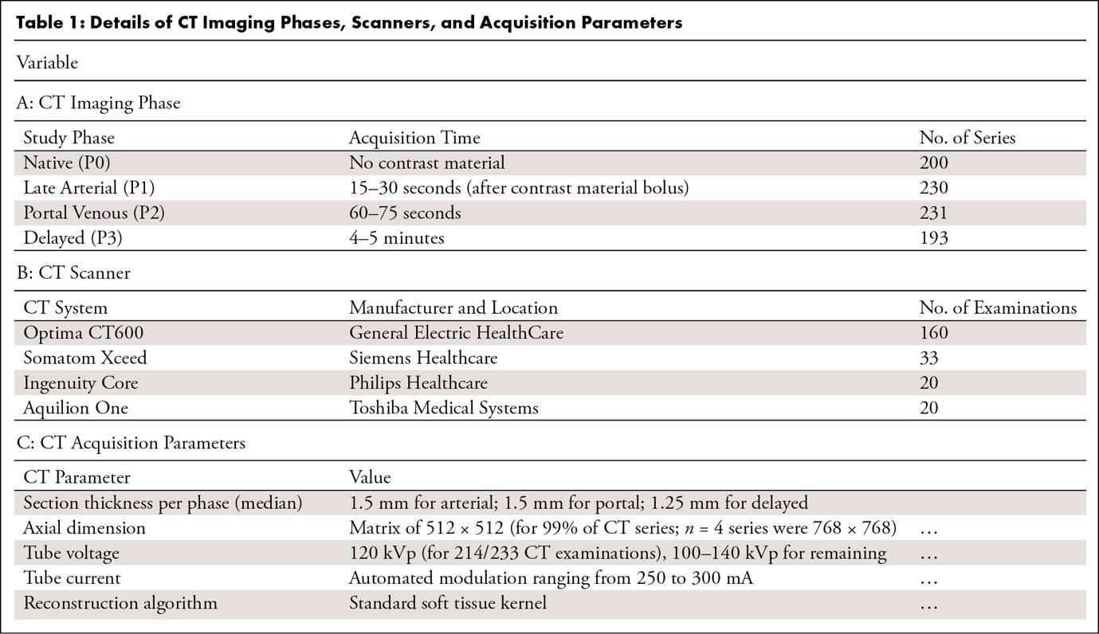
Table 1: Details of CT Imaging Phases, Scanners, and Acquisition Parameters. [Table 1 and its caption (34), CC BY 4.0]

Item 14 — Definition of method(s) used to obtain reference standard

Include a clear, detailed description of methods used to obtain the reference standard; readers should be able to replicate the reference standard based on this description. Include specific, standard guidelines provided to all annotators. Avoid vague descriptions, such as “white matter lesion burden,” and use precise definitions, such as “lesion location (periventricular, juxtacortical, infratentorial), size measured in three dimensions, and number of lesions as measured on T2/FLAIR MR brain images.” Provide an atlas of examples to annotators to illustrate subjective grading schemes (eg, mild, moderate, severe) and make that information available for review.
Explanation and Elaboration: A reference standard serves as the benchmark against which models are trained and experimental results are compared, making its clarity fundamental to the integrity of the study. Without a precise explanation of how this standard was established, other researchers cannot reliably replicate the methodology, validate the findings or understand the output the model is trained to produce. Therefore, authors should provide a detailed description of their methodology, including the measurement techniques used to generate the reference standard. This should include defining annotation protocols and outlining expert consensus processes when applicable.

Examples
T2-weighted MRI scans with varying lesion etiologies (traumatic, ischemic, hemorrhagic), injury chronicity (subacute, intermediate, and chronic), orientations (sagittal and axial), and voxel sizes were used for this study (Fig 1, Table 1). Lesions appearing as T2-weighted signal abnormalities (hyperintense or hypointense voxels corresponding to primary contusions, secondary cytotoxic edema, or hemorrhage) were manually annotated as a single object by two raters from site 1 (D.P. and L.F.), one rater from site 2 (A.C.S.), and by two raters (E.N.K. and J.V.) for site 3 using JIM (version 7.0; Xinapse Systems) and FSLeyes (version 1.9.0; University of Oxford) image viewers. As obtaining the reference standard spinal cord segmentation masks using a fully manual approach is time-consuming, sct_deepseg_sc … was used to initially segment the spinal cord of patients from all three sites, followed by manual corrections wherever necessary. This semiautomatic approach was also used in previous studies …. [Materials and methods (11), CC BY 4.0]
Follow-up information was acquired by matching with two validated national breast cancer and screening databases … accessed through the Danish Clinical Quality Program–National Clinical Registries (ie, RKKP). Positive and negative cancer outcomes were determined through histopathology-verified breast cancer or cancer-free follow-up, respectively, up until the next consecutive screening or within 24 months. [Materials and methods (22), CC BY 4.0]

Item 15 — Rationale for choosing the reference standard

Describe the rationale for choice of the reference standard versus any alternatives. Include information on potential errors, biases, and limitations of that reference standard.
Explanation and Elaboration: A good reference standard should minimize error and ambiguity, and align with the study's objectives. For example, in segmentation tasks, if the task is straightforward then the reference standard is often manual segmentation by an expert. If the segmentation task is challenging, or the decisions which it informs require high precision, then multiple human experts may be warranted. Alternatively, in cases where both the imaging system and segmentation contribute to error, or the contribution of each is unknown, a more rigorous evaluation may be necessary. This may be the case when an imaging modality is being used to measure a new tissue of interest it is not validated for. In this case, the reference standard may require physical measurement methods, such as dissection and direct tissue volume measurement, to establish a more objective reference. This principle applies broadly across AI research: when the chosen reference standard may obscure the contributions of different error sources or lacks precision, alternative or supplementary methods should be employed.

Examples
With no society recommendations on how to annotate and track the MV points, the Yale and Lund datasets were annotated according to two different principles. A single observer at Yale University (Yale observer) placed the MV points in the intersection between the MV and the LV myocardium, whereas the 9 observers at Lund University (Lund observers) placed the MV points at the most basal part of the compact LV myocardium. Both ways yielded similar MV motions but with a different reference point. However, due to the inherent observer bias and the high number of Lund observers, these annotations presented more variability. Such differences in manual annotation are very common in deep learning applications. [Methods, manual annotation section (35), CC BY 4.0]
Currently, manual segmentation is considered the reference standard for planimetric and volumetric measurements of brain structures at MRI. However, this approach is time- and resource-demanding and prone to inter- and intrarater variability, especially for small brain regions, thus limiting the usability of the above-mentioned neuroimaging biomarkers in routine clinical practice …. To overcome these issues, several studies have developed semi- or fully automated segmentation methods, adopting threshold- and landmark-based approaches …, as well as atlas-based segmentation strategies …. This decade, deep learning (DL) techniques have also been employed for the rapid and accurate segmentation of brain regions …. DL models learn to capture relevant features from raw images through a sequence of contracting and expanding paths of convolutions (encoder and decoder components) and generate as final output the desired segmentation masks …. [Introduction (36), CC BY 4.0]

Item 16 — Source of reference standard annotations

Specify the source of reference standard annotations, citing relevant literature if annotations from existing data resources are used. Specify the number of human annotators and their qualifications (eg, level of expertise, subspecialty training). Describe the instructions and/or training given to annotators; include training materials as a supplement.
Explanation and Elaboration: Reference standards are often based on human annotations; the quality of such a reference standard is heavily dependent on the quality of the annotation process and the skill of the annotators. Authors should specify whether annotations were generated prospectively or included retrospectively, who performed them, how many annotators were involved, and their qualifications (e.g., board-certified neuroradiologist with 10 years of experience). The annotation procedure should describe whether labels were assigned independently, in consensus, or with arbitration, and whether annotators had access to auxiliary data (e.g., clinical history, prior reports). Standardized instructions or training protocols should be reported to ensure reproducibility and minimize variability.

Exampless
Manual segmentation was performed independently by two board-certified radiologists initially (T.A.D. and H.C.B., with 12 and 7 years of experience, respectively). If an existing model for a given structure was publicly available (Appendix S3), that model was used to create the first segmentation, which was then reviewed and refined manually …. [Material and methods (37), © RSNA 2025]
The included referrals (n = 1953) were classified into suitable imaging protocols and use or no use of a gadolinium-based contrast agent by two fellowship-trained neuroradiologists (M.N., 16 years of experience, and J.H., 12 years of experience) in consensus, regarded as better reference standard than original instructions from radiologists of varying experience. [Methods (38), CC BY 4.0.]

Item 17 — Annotation of test set

Detail the steps taken to annotate the test set with sufficient detail so that another investigator could replicate the annotation. Include any standard instructions provided to annotators for a given task. Specify software used for manual annotation, including the version number. Describe if and how imaging labels were extracted from imaging reports or electronic health records using natural language processing or recurrent neural networks. This information should be included for any step involving manual annotation, in addition to any semiautomated or automated annotation.
Explanation and Elaboration: The software used for annotation—including the tool name and version—should also be specified. For example, in segmentation tasks, it is important to state the targeted structure or pathology, whether the annotation was manual or semi-automated, and if corrections were applied. If the study incorporated automated extraction of imaging labels from the electronic health record (such as radiology reports, pathology reports, or clinical notes), authors should describe the algorithms used for this purpose, such as natural language processing or recurrent neural networks. If label errors were known or suspected, authors should report whether reannotation or verification was performed. This is especially relevant for retrospectively sourced data, where labeling conditions may vary.

Examples
Six composite readers (see U.S. Study Details) participated in the U.S. and Japan study. Each reader interpreted half the cases without AI assistance and the other half with AI assistance. After a 1-month washout period, the readers then interpreted the same cases using the opposite method, resulting in each reader reading each case twice. Prior to both studies, an introductory presentation was given to walk through each of the questions asked per case. The purpose behind each question was covered along with a calibration guide of how to report the 0 to 100 LoS score. The AI system background and interface was presented, and a small pilot study of five cases was run to ensure comprehension. For the Japan study, relevant materials were translated into Japanese. Readers were informed that the case set was cancer enriched but were not given an exact percentage. For each evaluation, the readers provided the following: (a) an LoS value between 0 and 100 inclusive to indicate their suspicion of malignancy for the patient as a whole, (b) a score based on the respective country-specific scoring system (Lung-RADS v1.1 score for United States and Sendai score for Japan), and (c) a case management recommendation (readers could choose a recommendation different from those in the guidelines). All responses were evaluated against a single ground truth of cancer positivity within 2 years of imaging.
… The U.S. study involved 330 patients (median age, 63 years [range, 49–82 years]; 191 male and 139 female patients) and a total of eight (six effective) U.S. board-certified thoracic radiologists (mean years of experience, 17 [range, 7–30 years]). Midway through the study, two readers became unavailable and were replaced by two new readers. Thus, an effective total of six radiologists participated in the study. All paired reads of the same case were conducted by the same reader. For the country-specific scoring system, radiologists applied Lung-RADS score (version 1.1) from the ACR guidelines …. Readers used the eUnity web-based picture archiving and communication system (PACS) viewer (Mach7 Technologies) to read cases. [Material and methods (39), CC-BY 4.0]
Manual segmentations were performed by medical students in their final year of training (J.H. and S.R.) who were supervised by two board-certified radiologists. ... The liver, erector spinae muscle and psoas muscle were segmented manually in ITKsnap by selecting the organ tissue on every second slide of the water-separated images and applying the interpolation function. The entire liver was selected, excluding larger vessels. The psoas muscle was selected starting from the insertion points at the vertebrae down to the lesser trochanter, and the erector spinae muscle selection included inter- and intramuscular fat, as shown in other works. The semiautomatic VAT/SAT segmentation tool (vatsatseg) … (https://github.com/maxdiefenbach/vatsatseg) was used to generate masks for subcutaneous adipose tissue (SAT). The FatSegNet … was used to extract visceral adipose tissue (VAT). The final VAT label was obtained by manually erasing adipose tissue above the diaphragm and below the pubic bone, thus excluding epicardial and thoracic fat. Consistent segmentation borders for SAT were achieved by choosing the liver dome and the center of the femoral head as cranial and caudal segmentation borders. The ground truth label generation of SAT was based on the vatsatseg tool, which provided more complete SAT segmentations compared with the fully automated FatSegNet tool. [Methods and appendix sections (40), CC-BY 4.0]

Item 18 — Measures of inter- and intra-rater variability of features described by the annotators

Describe the methods to measure inter- and intra-rater variability, reduce or mitigate variability, and/or resolve discrepancies between annotators.
Explanation and Elaboration: Inter- and intrarater variability should be reported to assess the consistency of annotations used in training or evaluating AI models. Confusion between agreement and reliability is common. Agreement measures how closely raters match each other’s labels, while reliability reflects the ability to consistently distinguish between classes. Common measures for categorical data include Cohen’s kappa (two raters) and Fleiss’ kappa (multiple raters) (41). For continuous or ordinal data, the intraclass correlation coefficient (ICC) assesses reliability, while agreement is often shown with a Bland–Altman plot. Annotation conditions should be specified, including time intervals for repeated measures (test–retest reliability). Statistical methods used to quantify variability should be detailed, including their context (e.g., kappa > 0.8 often reflects strong agreement, though thresholds may vary) (41). Methods to mitigate variability include structured training, accounting for learning effects, and standardized protocols. Calibration sessions can align annotators on definitions before formal labeling. Blinding raters to clinical data and AI outputs can help maintain consistency. All steps taken to reduce variability should be reported. Discrepancies can be resolved through majority vote, consensus, or expert adjudication. These approaches have different strengths; rationale and potential influence on results should be reported. For subjective or complex imaging features, variability may be higher; in such cases, thresholds for agreement should be justified and supported by prior work, if available.

Examples
The interstudy repeatability was assessed with interclass correlation coefficient (ICC) and Bland-Altman analysis to compare the scan-rescan variation in the automated and manual cardiac MRI measurements. The paired t test was calculated to compare the differences in scan-rescan measurements between AI and manual assessment….
The interstudy repeatability of cardiac MRI measurements was high for both AI and manual measurements. The automatic LV and RV volumetric and mass measurements ICC were 0.92 and 0.99, respectively. The ICC for LV and RV ejection fraction was 0.80 and 0.90, respectively (Table 5). [Methods and results (42), CC-BY 4.0]
A Bland-Altman plot comparing the AI-derived and expert CACS is depicted in Figure S1, revealing a bias of 5.06 Agatston units, with 95% LOA from −287.42 to 297.55. Stratified analysis per scanner manufacturer showed a bias of 4.67 (95% LOA: −118.65 to 127.99) for Siemens Healthineers, 5.83 (95% LOA: −341.36 to 353.02) for Canon, and 3.23 (95% LOA: −348.72 to 355.19) for Philips scanners.
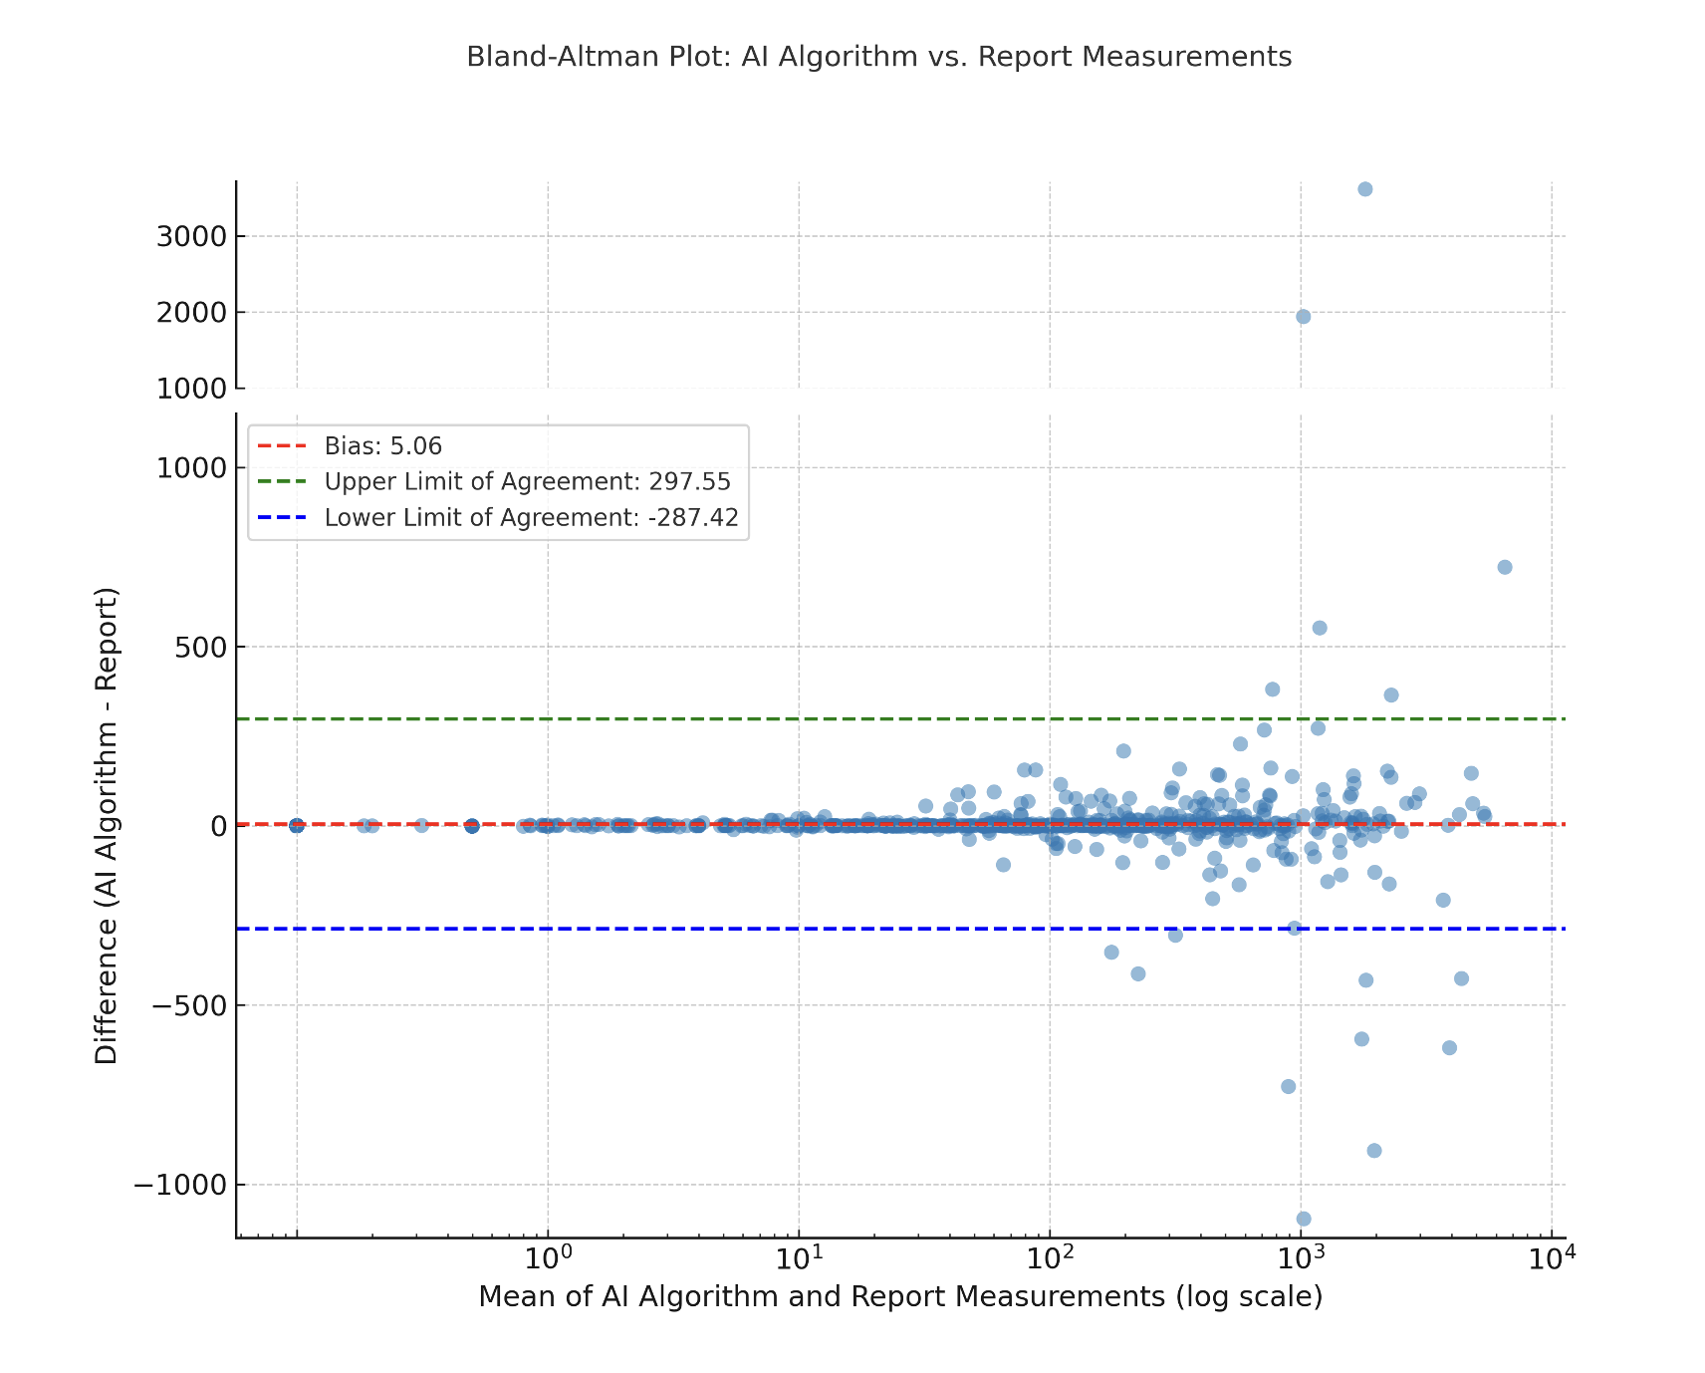
Figure S1: Bland-Altman plot between coronary artery calcium scoring in Agatston units obtained from original cardiac CT report and AI algorithm. [Results and Figure S1 (43), © RSNA 2025]

Item 19 — How data were assigned to partitions

Specify how data were partitioned for training, model optimization (often termed “tuning” or “validation”), and testing. Indicate the proportion of data in each partition (e.g., 80/10/10) and justify that selection. Indicate if there are any systematic differences between the data in each partition, and if so, why and how potential class imbalance was addressed. If using openly available data, use established splits to improve comparison to the literature. If freely sharing data, provide data splits so that others can perform model training and testing comparably.
Explanation and Elaboration: Tuning and testing partitions must be large enough to calculate performance metrics with appropriately narrow confidence intervals – see Item 21. When there are class imbalances, stratified sampling may be necessary to ensure adequate representation in all partitions. Test partitions are often annotated differently than training partitions, such as using multiple annotators for test and single annotators for training. Any such differences should be justified and potential biases introduces should be discussed.

Examples
We randomly divided eligible patients from the primary cohort into a training set (n = 507) and a validation set (n = 218) at a 7:3 ratio. [Materials and methods (44), CC-BY 4.0]
The data is split into training, validation, and testing sets with ratios of 50 %, 20 % and 30 % respectively. We train our model on the training set and use the validation set for evaluation. The best hyperparameters are then tested on unseen testing data. For Casc-UNetS, tuning is done separately for each stage. For UNetS1, hyperparameters are tuned with and without CLAHE. For UNetS2 and 3, only CLAHE MRI are used due to improved validation losses. [Methods (45), CC-BY 4.0]
The cohort of 9919 women (13 306 DBT examinations) was split into a training set of 3948 women (804 cancers [20.3%]), a validation set of 1661 women (182 cancers [11.0%]), and a test set of 4310 women (453 cancers [10.5%]) (main test). Examinations in the same woman appear within only one of these data sets. The training data set included examinations from 18 imaging facilities. The validation set was used for model selection and calibration of the AI model (Appendix E1 [online]). A subset of the main test (Fig 2C, Table E1 [online]), which we named sites test (2375 women), included examinations from four sites and was used to test the generalizability of AI to unseen sites. [Methods (46), CC-BY 4.0]

Item 20 — Level at which partitions are disjoint

Describe the level at which the partitions are disjoint (eg, patient-, series-, imagelevel). Sets of medical images generally should be disjoint at the patient level or higher so that images of the same patient do not appear in more than one partition.
Explanation and Elaboration: Ideally, the level of independence between data in the training and test partitions is equal to the level of independence between training data and data that the model will see in production deployment. Partitioning at levels below the patient (such as exam, series or image level) introduces significant risks of decreased data independence that can severely compromise model evaluation. When images from the same patient appear in different partitions, the model may learn patient-specific features rather than generalizable patterns, leading to artificially inflated performance metrics during testing. If data are partitioned below the patient level, the decision should be justified.

Examples
A total of 1143 scans (616 MRI, 527 CT) were split into the training set (n = 1088; CT and MRI scans) and internal test set (n = 55; only MRI scans) at the patient level. [Results (37), ©RSNA 2025]
The remaining dataset was randomly split at the patient level in the ratio of 80% and 20% for training and validation respectively. [Methods (47), CC-BY 4.0]

Item 21 — Intended sample size

Describe the size of the testing set and how it was determined. Use traditional power calculation methods, if applicable, to estimate the required sample size. For classification problems, in cases where there is no algorithm-specific sample size estimation method available, sample size can be estimated for a given area under the curve and confidence interval width…
Explanation and Elaboration: The size of the test set or partition should be chosen based on the acceptable level of uncertainty in performance metrics, not simply as an arbitrarily selected percentage of the number of items in the full dataset. Power calculations should be performed based on the specific performance metrics intended to be used as the primary measures or outcomes. Targeted uncertainty (e.g. confidence interval width) should be based on clinical judgment and justified.
Examples
To determine the sample size required for the comparison between the network and radiologists, we assumed a mean Dice score of 0.75 as the lower bound for the radiologist and of 0.80 as the lower bound for the network. Power analysis for a paired t test was performed with logit-transformed Dice scores to approximate normality …. Use of an estimated standard deviation of 1.5 across examinations (based on the network performance in the validation set) resulted in Cohen d of 0.1918. With this effect size, a power of 85% at a significance of 5% required 246 scans. We selected a sample size of 250 scans for the test set. [Materials and methods (48), CC BY 4.0]
Sample size was calculated using a previously developed equation…. To estimate sensitivity and specificity for task 4 of 0.7 … with a 95% CI, a precision of 10%, and an expected prevalence of causal findings of 20%, the number of reports should be at least 400. With approximately 20% … of emergency MRI examinations performed for headache in our institution, at least 2000 reports were screened. [Materials and methods (24), CC BY 4.0]
G*Power version 3.1 (The G*Power Team) was used to determine the sample size …. A recent study reported a median difference of 1.9 months ± 0.4 (SD) between the estimated age and the corrected chronologic age …. Therefore, a sample size of 833 was sufficient to reach a minimum 80% power and 5% error rate according to a two-sided t test. [Materials and methods (49), © RSNA 2023]

Item 22 — Detailed description of model

If novel model architecture is used, provide a complete and detailed structure of the model, including inputs, outputs, and all intermediate layers, in sufficient detail that another investigator could exactly reconstruct the network. For neural network models, include all details of pooling, normalization, regularization, and activation in the layer descriptions. Model inputs must match the form of the preprocessed data. Model outputs must correspond to the requirements of the stated clinical problem, and for supervised learning should match the form of the reference standard annotations. If a previously published model architecture is employed, cite a reference that meets the preceding standards and fully describe every modification made to the model. Cite a reference for any proprietary model described previously, as well. In some cases, it may be more convenient to provide the structure of the model in code as supplemental data.
Explanation and Elaboration: A full description of model architecture is essential to ensure that other researchers can replicate the model or build upon the study. Checking that model inputs match what was described for preprocessing steps helps to identify steps that may have been performed but not described. For instance, if a network operating on radiographs takes a fixed input size of 224 x 224 pixels but there is no downscaling step described in the preprocessing, something is clearly missing. Similarly, if the output of the model is not directly applicable to the stated clinical problem either the model will not be clinically useful or there are post-processing steps that must be described. Large models may be difficult to succinctly but completely describe in prose, and it may not be apparent when there are missing details. Code that constructs the model using a widely used framework may be a more direct and useful means of fully specifying the model than a natural language (e.g. English) description.

Examples
Specifically, a DL-based segmentation model was developed for each target structure by using a network based on encoder-decoder architecture, that is, ResNet-50–U-Net …. The encoder ResNet-50 extracted features from the original image, and the decoder U-Net completed the fusion of information based on these features, thereby completing the pixel-by-pixel prediction of input image. In more detail, ResNet-50 is a 50-layer convolutional neural network that uses skip connections to propagate information over layers, allowing for increased depth of the network and higher performance levels compared with other models …. The ResNet-50 was pretrained on the ImageNet 2012 classification dataset (https://www.image-net.org/), which comprises 1000 classes and 1.28 million training images. The pretrained weights were obtained from a public repository (https://github.com/fchollet/deep-learning-models/releases/download/v0.2/resnet50_weights_tf_dim_ordering_tf_kernels.h5). The training of each DL model was performed in five epochs using the Adam optimizer with an initial learning rate of 0.01. Moreover, data augmentation was used to increase the size of the training dataset to enhance the performance of DL models. Specifically, data augmentation was achieved by rotating (−30° < angle θ < 30°) and translating images by −20% to 20% on the x- and y-axis independently. [Materials and methods (36), CC BY 4.0]
Classification ensemble constituents used a modified InceptionV3 architecture …. Input layers were adjusted to accept 764 × 764-pixel and 1024 × 1024-pixel resolution DICOM files. The classification head consisted of a global average pooling layer, followed by a dense layer with rectified linear unit … activation and a dropout layer. A softmax activation function was applied to the final dense layer. Model ensemble output probabilities were calculated by averaging probabilities of each constituent model. The number of neurons in the penultimate dense layer and the dropout rate were tunable hyperparameters optimized during training using the Hyperband algorithm …, with the best set of parameters corresponding to the lowest categorical cross-entropy loss on the validation set. The number of neurons was selected from the range of [32, 512], and the dropout rate took values from the range [0, 0.2]. Models were trained in two phases. In the first phase (pretraining), networks were initialized with ImageNet weights … and trained to differentiate normal and abnormal chest radiographs using transformer-generated ground truths from 1 132 142 DICOM images and linked radiology reports (Fig 1). In the second phase (classification), models were initialized with the pretrained weights and further fine-tuned on manually annotated NGT DICOM images. Training was performed with 32 images per batch using an Adam optimizer with a learning rate of 1 × 10−3 while minimizing the categorical cross-entropy loss. Input images were resized to 764 × 764 or 1024 × 1024 pixels using bilinear interpolation without preserving the aspect ratio. During training, images were subject to random augmentations, which included brightness adjustments, angular rotation, and left-to-right flipping. Training was terminated early if validation loss did not improve after 10 consecutive epochs. [Materials and methods (50), CC BY 4.0]

Item 23 — Software libraries, frameworks, and packages

Specify the names and version numbers of all software libraries, frameworks, and packages used for model training and inference. A detailed hardware description may be helpful, especially if computational performance benchmarking is a focus of the work.
Explanation and Elaboration: Capabilities and performance of software often varies between implementations and versions; reproducibility requires knowing exactly which software was used. If dependencies are managed using virtual environments (e.g., Conda, Docker, virtualenv), provide configuration details or environment files. Since hardware is abstracted by software layers such that models can run on a variety of hardware, detailed descriptions of hardware models and specifications are generally relevant only when the study involves computational performance benchmarking. When there are minimum hardware requirements for training or inference (e.g. GPU memory) it is helpful to state these.
Examples
MyoMapNet was implemented in Python using the PyTorch library (1.4.0). Training, validation, and testing were performed on a DGX-1 workstation (NVIDIA Santa Clara, California, USA) equipped with 88 Intel Xeon central processing units (2.20 GHz), one NVIDIA Tesla V100 graphics processing unit (GPU) with 32 GB memory and 5120 Tensor cores, and 504 GB RAM. [Materials and methods (51), CC BY 4.0]
MD-CNN was implemented in Python using the PyTorch library version 0.41.... All models in this work were trained and tested on an NVIDIA DGX-1 system equipped with 8T V100 graphics processing units (GPUs; each of 32 GB memory and 5120 cores), central processing unite (CPU) of 88 core: Intel Xeon 2.20 GHz each, and 504 GB RAM. Only four GPUs were used to train MD-CNN. The total MD-CNN training time was 24 h. [Materials and methods (52), CC BY-NC 4.0]

Item 24 — Initialization of model parameters

Indicate how the parameters of the model were initialized. Describe the distribution from which random values were drawn for randomly initialized parameters. Specify the source of the starting weights if transfer learning is employed to initialize parameters. When there is a combination of random initialization and transfer learning, make it clear which portions of the model were initialized with which strategies.
Explanation and Elaboration: Initialization of model parameters is a critical aspect of AI model training that profoundly influences convergence, stability, and overall performance (53). When a deep learning model is trained from scratch, the distribution from which the randomly initialized weights are drawn can influence model convergence. More commonly, models are initialized from a previously trained model (transfer learning).

Examples
We constrained the weights incident to each hidden unit to have a norm value of less than or equal to 3, the weights of the layers were randomly initialized by using He normal initialization …, and the network was trained with a batch size of 36 for 15 epochs and optimized by using the Adam algorithm … with a learning rate of 0.001. [Materials and methods (54), CC BY 4.0]
Models were trained in two phases. In the first phase (pretraining), networks were initialized with ImageNet weights … and trained to differentiate normal and abnormal chest radiographs using transformer-generated ground truths from 1 132 142 DICOM images and linked radiology reports (Fig 1). In the second phase (classification), models were initialized with the pretrained weights and further fine-tuned on manually annotated NGT DICOM images. [Materials and methods (50), CC BY 4.0]

Item 25 — Details of training approach

Describe the training procedures and hyperparameters in sufficient detail to enable another investigator to replicate the experiment. To fully document training, a manuscript should: (a) describe how training data were augmented (eg, types and ranges of transformations for images), (b) state how the convergence of training of each model was monitored, and what the criteria for stopping training were, and (c) indicate the values that were used for every hyperparameter, including which of these were varied between models, over what range, and using what search strategy. For neural networks, descriptions of hyperparameters should include at least the learning rate schedule, optimization algorithm, minibatch size, dropout rates (if any), and regularization parameters (if any). Discuss what objective function was employed, why it was selected, and to what extent it matches the performance required for the clinical or scientific use case. Define the criteria used to select the best-performing model. If some model parameters are frozen or restricted from modification, for example in transfer learning, clearly indicate which parameters are involved, the method by which they are restricted, and the portion of the training for which the restriction applies. It may be more concise to describe these details in code in the form of a succinct training script, particularly for neural network models when using a standard framework.
Explanation and Elaboration: Describing the training approach in sufficient detail to enable exact replication is essential for reproducibility and understanding the AI model’s development – nothing should be left to guesswork or experimentation. The Checklist enumerates multiple items that are commonly required to permit replication, but this should not be considered an exhaustive or limiting list: everything required for replication should be included. Frequently, the primary metric used to assess model performance is not well suited as an objective function in training (e.g. due to differentiability or computation requirements). In these circumstances it is particularly important to explain the choice of objective function and discuss how it differs from the targeted metric.

Examples
Model Implementation and Initialization
All models are implemented using PyTorch …, in an in-house library (https://github.com/CCIG-Champalimaud/adell-mri) using the default initialization in PyTorch for all layers excluding positional embeddings (initialized with a truncated normal distribution with mean 0, standard deviation 0.02 and lower and upper bounds set to-2 and 2, respectively).
Augmentations
We used a wide array of augmentations from MONAI …, namely:
- Identity (no transform)
- Random contrast adjustment (γ = [0.5, 1.5])
- Random standard shift in intensity (range = [−0.1, 0.1])
- Random shift in intensity (range = [−0.1, 0.1])
- Random Rician noise (std = 0.02)
- Random bias field (degree = 3 (T2W-only))
- Affine transforms (translation range = [4, 4, 1], rotation range= [π/16, π/16, π/16])
- Horizontal flip
Each study is augmented with one of the aforementioned transforms, which is picked at random with uniform probability.
Training
Each model is trained for 100 epochs and the best-performing checkpoint on the validation set is picked for further evaluation (this avoided the optimization of an early stopping criteria). For training, we used an AdamW optimizer … with the learning rate/weight decay parameters specified above; a binary cross-entropy loss was used. [Supplementary material (55), CC BY 4.0.]
All experiments are conducted on the PyTorch platform with two NVIDIA TITAN RTX GPUs (24GB). We use the ADAM optimizer to optimize all networks. The initial learning rates of the whole-breast and tumor segmentation models are 0.002 and 0.001, respectively. And, the learning rate decays by half for every 50 epochs. A total number of 300 epochs are set for each task. We compute the training loss within 10 epochs to determine the convergence. While using the well-trained segmentation models to test the results, we use sliding windows to crop the overlapping patches, whose stride is half of the patch size. Then, we average the overlapping patches to obtain the final results. [Methodology (56), CC BY 4.0.]
In the training phase, volumetric data from all individuals in the training set were harmonized using ComBat…. with empirical Bayes optimization to remove scanner-related batch effects. While training, we imposed constraints that preserve the effects of age, sex, and cognitive status. Cognitive status was dichotomized based on the clinical diagnosis as either no-cognitive impairment (Healthy Controls and Subjective Cognitive Decline) or cognitive-impairment (Mild Cognitive Impairment and Alzheimer’s Disease). Subsequently, a random forest regressor was trained with MRIQC-derived image quality metrics to predict the corrections needed to harmonize the volumes as predicted by ComBat. Additionally, to preserve disease-related signals during harmonization, we used the synthetic minority oversampling technique … to avoid class imbalance (no cognitive impairment vs cognitive impairment) before training the random forest regressor. This ensured that image quality metric values with and without neurodegeneration were equally distributed. Using dichotomized cognitive status instead of clinical diagnosis ensured that in the test phase, a full clinical diagnosis was not required to predict the harmonized volumes. The hyperparameters for the random forest regressor were chosen to be the same as the ones used in the original Neuroharmony article. [Materials and methods (10), CC BY 4.0.]

Item 26 — Method of selecting the final model

Describe the method and metrics used to select the best-performing model among all the models trained for evaluation against the held-out test set. If more than one model was selected, justify why this was appropriate.
Explanation and Elaboration: Typically, many variations on a model will be trained as part of model and hyperparameter optimization, but in general, only one final model should be evaluated on the held-out test set. Criteria for determining which of these models is selected as the “best” final model should ideally be determined in advance and must be clearly described. Absence of clear methodology for model selection raises concern that multiple models may have been evaluated against the held-out test set and the best performing model selected. Since there is some random variability in the performance of any model based on the items included in the test set, this multiple testing biases the reported metrics to be higher than the actual expected performance of the model. In some cases there may be multiple related objectives for model development and it may be appropriate to select a small number of final models that are “best” for different criteria (e.g. favoring sensitivity or favoring specificity, or for ensembling). In such cases, the decision to select more than one model requires justification and each set of selection criteria should be detailed.

Examples
We independently trained 10 deep learning models to predict malignancy from a single image. ... Multiple models were trained over a few variations of data sources, image types, malignancy time windows, and binary prediction tasks to produce the model bank outlined in Table S2. Such a diversity of complementary models helped the high-level vision system achieve higher performance by providing a rich image descriptor. ... Metamodels were trained using a random hyperparameter search for 50 iterations and five-fold cross-validation with four repeats. During 50 iterations, we selected the four sets of hyperparameters that yielded the best performance in terms of area under the receiver operating characteristic curve (AUC), mean rule-out-rate (ie, mean specificity in a sensitivity range of 95%–100%), rule-out rate (ie, specificity at 99% sensitivity), and ROC equality point (ie, the point at which sensitivity equals specificity). The final metamodel was an averaged ensemble of these four metamodels with uniform weights. ... After the model training phase, the model operating point was calculated based on the validation dataset composed of only cancer-positive samples from the US Dataset 1 and UK Dataset 3 validation data at two target sensitivity levels: 0.99 and 0.97, resulting in thresholds T = 0.02094 and T = 0.03584. A bootstrapping method was utilized as a form of interpolation. The cancer positive validation dataset, which comprised 646 mammograms (106 from US Dataset 1, 540 from UK Dataset 3), was sampled with replacement resulting in 2000 bootstrapped datasets, each composed of 646 mammograms (not all input mammograms are present in a given bootstrap sample and some are repeated due to sampling with replacement). For each bootstrapped dataset, the operating point was chosen by selecting the mammogram from the set such that less than a fraction S of the examinations have a smaller model-predicted probability of cancer (this is equivalent to finding the S-percentile of model outputs). The final operating point was then calculated as the mean operating point chosen over the 2000 bootstrap samples. The evaluation study was performed at two sensitivity levels: S=0.99 and S=0.97. [Appendix S2. Model Development (23), CC-BY 4.0]
Because T2-weighted and synthetic MCE MRI images are anatomically coregistered, kidney masks created on T2-weighted images provide ground truth for training segmentation models on synthetic images. Thus, four Mask R-CNN models (Smodels 1, 2, 3, and 4) were trained using the synthetic images of each of the MCE MRI phases and the T2-weighted masks as input. ... To train Mask R-CNN models, we used the gray-scale images as input and the binary kidney masks as ground truth (512 × 512). We set a batch size of four, a number of epochs of 100, an initial learning rate of 0.008 with a momentum optimizer of 0.9, and a gradient clipping by a norm of 10. The optimal model was selected based on the minimum of the validation loss. With the pretrained weights, the Mask R-CNN models were trained using synthetic datasets for each MCE MRI phase. [Materials and methods (57), CC-BY 4.0]

Item 27 — Ensembling techniques

If the final algorithm involves an ensemble of models, describe each model comprising the ensemble in complete detail in accordance with the preceding recommendations. Indicate how the outputs of the component models are weighted and/or combined.
Explanation and Elaboration: Ensembling is the process of combining predictions from multiple models to improve the overall performance of an algorithm. Ensembles can leverage the strengths of each component model. Common techniques to create ensemble models include bagging, boosting, stacking, and voting (58).Authors should provide the rationale behind the technique used to ensemble, including detail any experiments done to determine the most optimal technique.

Examples
We trained a set of U-Net convolutional neural network models to perform two-dimensional lung segmentation on the collected neonatal MR images, with each model (models 1–3) based on the manual annotations of every rater, and combined them through pixelwise majority voting to a model ensemble (ME) (Fig 2).
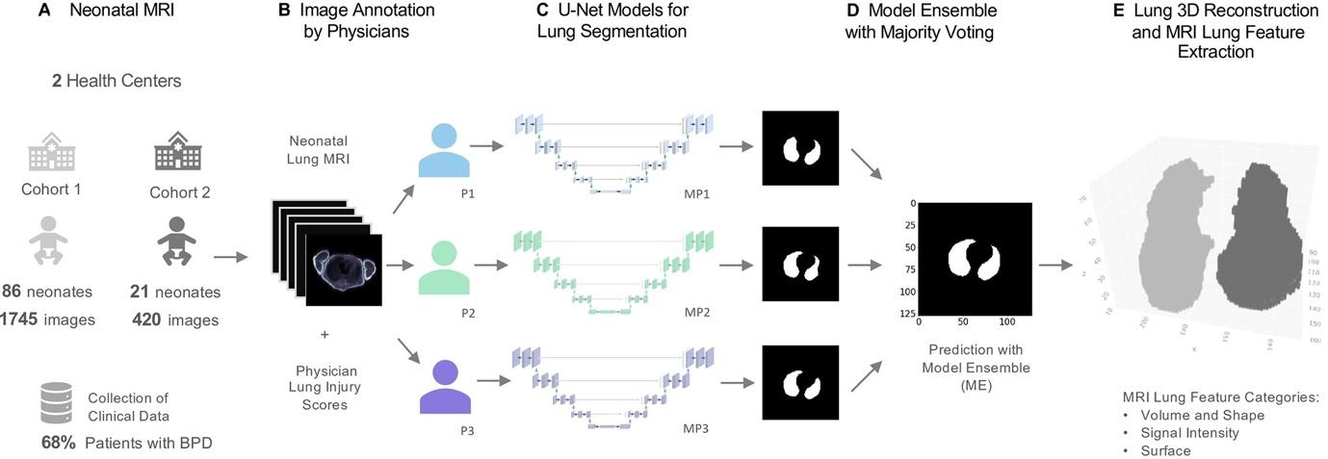
Figure 2: MRI-based neonatal lung segmentation and automated MRI analysis. (A) Clinical study including preterm infants with and without bronchopulmonary dysplasia (BPD). Free-breathing neonatal MRI was performed at mean gestational age of 37 weeks ± 5.8. (B) Manual MRI annotation of the lung was performed by three trained physicians (physician 1 [P1], physician 2 [P2], and physician 3 [P3]). MRI morphologic injuries (eg, emphysema, fibrosis, ventilation inhomogeneity) were scored by two trained physicians. (C, D) U-Net deep learning models (MP1, MP2, MP3) were trained for lung segmentation, and a final lung-mask prediction was calculated with an ensemble of the models (ME) through majority voting. (E) Lung volume three-dimensional (3D) reconstruction and automated calculation of 78 lung morphologic 3D descriptors. [Material and methods, Figure 2 and its caption (59), CC-BY 4.0]
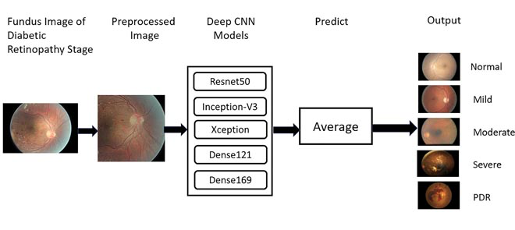
The proposed approach ensembles the five deep CNN models Resnet50 …, Inceptionv3 …, Xception …, Dense - 121 …, Dense169 …. Algorithm 1 presents the proposed model in detail. Let H= {Resnet50, Inceptionv3, Xception, Dense121, Dense169} be the set of pre-trained models. Each model is fine tuned with the Fundus Images dataset (X,Y) ; where X the set of N images, each of size, 512×512 , and Y contain the corresponding labels, Y={y/y∈{Normal,Mild,Moderate,Severe,PDR}}. [Methods section, Equation 3, and summary figure (60), CC-BY 4.0]

Item 28 — Metrics of model performance

Describe the metrics used to assess the model’s performance and indicate how they address the performance characteristics most important to the clinical or scientific problem…. Compare the presented model to previously published models.
Explanation and Elaboration: There are a wide variety of performance metrics available for evaluating models, some common in data science and others more common in diagnostic medicine. Select metrics that focus on measuring the aspects of performance that are most relevant to the specific problem you are addressing. Typically, these are metrics commonly found in non-AI medical diagnostics manuscripts, such as sensitivity, specificity, and area under the receiver operating characteristic curve (AUC-ROC). Metrics that are dependent on prevalence, including positive and negative predictive values and overall accuracy, should be avoided unless prevalence in the test set is similar to the population to which the model will be applied. It may be appropriate to secondarily report non-medical metrics commonly used in AI to facilitate comparison with other models.
Examples
The ability of the system to detect tumors was assessed by calculating the area under the receiver operating characteristic curve (ROC AUC) and generating a confusion matrix. Automatically generated binary masks were resampled to the original image resolution using cv2.INTER_BITS interpolation before comparing with manual segmentations. The contouring performance of the proposed pipeline, as well as the doctor's variability, were assessed by using the volumetric Dice similarity coefficient (DSC), Jaccard index (Ji), and 95th percentile Hausdorff distance (H95th). Additionally, we have evaluated quantitative contouring performance using Surface DSC and Added Path Length (APL). [Methods (61), CC-BY 4.0]
To compare pixel-level performance between the baseline and semi-supervised models, we collected 1000 sets of 529 images by conducting random sampling with replacement on the images comprising the pixel-labeled CQ500 test set. We obtained the estimated differences in the Dice similarity coefficient (ΔDSC) between the baseline and semi-supervised models on all 1000 bootstrapped sets of 529 images and confirmed that the ΔDSC are normally distributed at a confidence level of P less than .05 using a standard Kolmogorov-Smirnov test for normality. We then calculated test statistic (Z = ΔDSC/σ, where σ is the empirical SD of the DSC differences on the 1000 bootstrapped sets of 529 images) and calculated a two-sided P value as twice the probability that a standard normal random variable is less than |Z|. [Materials and methods (62), CC-BY 4.0]
In addition, to compare the diagnostic efficacy of the AI system with that of the junior radiologists as well as that of the radiologists under the assistance of AI, we calculated the sensitivity, specificity, and accuracy together with their 95% confidence intervals as well as the AUC. In addition, the Z-value test was used to compute P-values for statistical comparisons between different groups for evaluation metrics other than the AUC values, whose comparison was done instead using the DeLong test…. [Methods (63), CC-BY 4.0]

Item 29 — Statistical measures of significance and uncertainty

Indicate the uncertainty of the performance metrics’ values, such as with standard deviation and/or confidence intervals. Compute appropriate tests of statistical significance to compare metrics. Specify the statistical software, including version.
Explanation and Elaboration: Uncertainty is inherent in any measurement of model performance, since metrics are calculated based on a sample (the test set). Metric values are essentially uninterpretable without quantification of this uncertainty. Wherever the manuscript makes direct comparison between values (e.g. comparing different models), an appropriate statistical test should be employed to estimate the probability that the observed difference may be due to chance (the p-value). Working with a statistician helps to ensure the analysis is accurate, detailed, and methodologically sound. Statisticians are cautioned that commonly used tests that are well understood by scientists who are not statistics experts should be preferred to novel tests; novel statistical methods should be reserved for circumstances that cannot be addressed by simpler techniques. Statistical software version should be reported to facilitate enhance reproducibility and facilitate detection of errors if the software is later determined to have bugs.

Examples
Standard descriptive statistics were used on a per-study level to compare iPE detection rate and characteristics. The chi-square test was used for comparing categorical variables. The exact Clopper-Pearson interval was used for calculating CIs for proportions. Categorical data are presented as percentages, and continuous data as the mean ±1 SD. P < .05 was considered statistically significant. SPSS Statistics for Windows, version 27 (IBM Corp.), was used for all analyses. [Materials and method (64), CC BY 4.0]
To determine whether the features generated by a model were biased, we used two-sample Kolmogorov–Smirnov tests to determine P values for the null hypothesis that the marginal distributions for a given pair of subgroups are identical in each of the first four modes of PCA. These statistical tests were performed for all relevant pairwise comparisons regarding the presence of disease, biologic sex, and race. The P values were adjusted for multiple testing using the Benjamini–Yekutieli procedure, and significance was determined at a 95% confidence level (P < .05).
To evaluate and compare the disease detection performance of different models, we computed the AUC, true-positive rate (TPR), and false-positive rate (FPR). TPR and FPR in subgroups were determined at a fixed decision threshold, which was optimized for each model to yield an FPR of 0.20 on the whole patient sample. The fixed target FPR allows for immediate identification of performance deviations across subgroups. To provide a single measure of classification performance, we report the Youden J statistic (measured at the target FPR), which is defined as J = TPR − FPR. We used bootstrapping with 2000 samples to calculate 95% CIs. [Materials and method (65), CC BY 4.0]

Item 30 — Robustness or sensitivity analysis

Analyze the robustness or sensitivity of the model to various assumptions or initial conditions.
Explanation and Elaboration: Analyses involve systematically evaluating how variations in inputs or parameters affect the model’s performance. Many different sensitivity analyses can be performed for a given model; these do not all have equal value. Favor evaluating robustness with respect to things that are likely to vary or change in application of the model or technique developed in the manuscript. For a model intended for clinical application, this may include features of the input data and setpoints. Evaluating sensitivity to hyperparameters is generally much less informative, unless the focus of the work is methods for training models. Ultimately the goal of these analyses is understanding how well the AI solution can tolerate the inevitable fluctuations and drifts encountered in clinical and scientific applications.

Examples
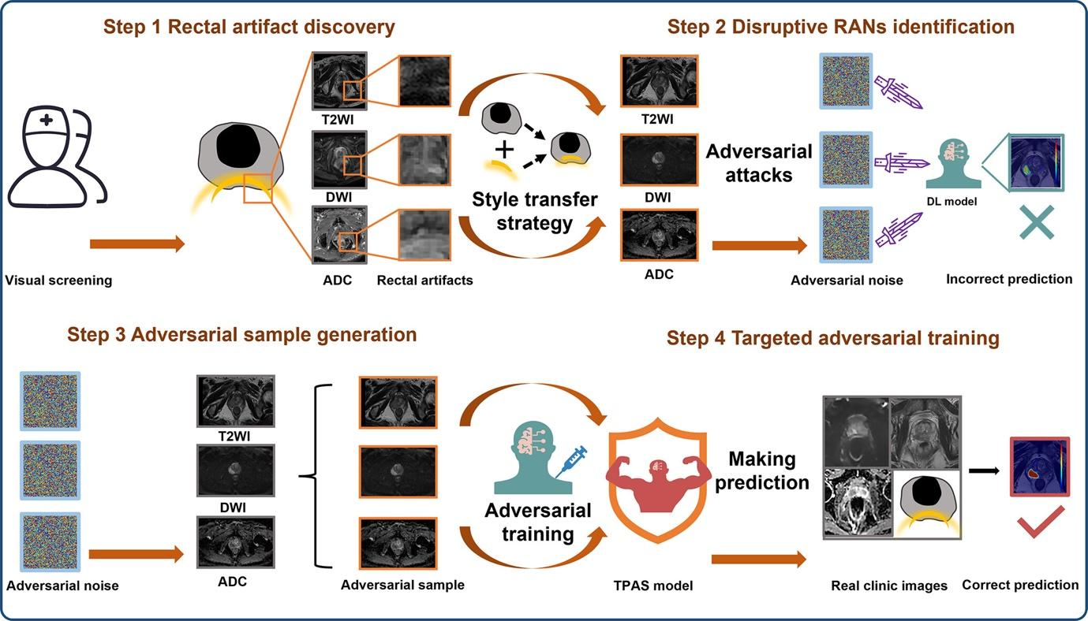
Figure 2. The targeted adversarial training with proprietary adversarial samples (TPAS) strategy diagram. The TPAS strategy includes four steps. Step 1: In the pre-experimental phase, we identified images with severe rectal artifacts that caused misjudgment in multiple DL models. Step 2: We extracted RAN features that disrupted the DL model to generate rectal artifact–pattern adversarial noise. This was achieved by incorporating a style transfer strategy with an adversarial attack strategy. Step 3: We created three types of rectal artifact–pattern adversarial noise, similar to the RAN in T2-weighted imaging, DWI, and ADC studies. These were added to generate proprietary adversarial samples. Step 4: The adversarial samples were then used for targeted adversarial training to enhance the model’s resistance to RAN. ADC = apparent diffusion coefficient, DL = deep learning, DWI = diffusion-weighted imaging, RAN = rectal artifact noise, T2WI = T2-weighted imaging. [Figure 2 and its caption (21), CC BY 4.0]
In the DCE MRI sequence, various temporal phases are designated as time 0 through time 5. Time 0 is identified as the phase prior to contrast enhancement, while time 1 to time 5 represent successive contrast-enhanced phases following the initial noncontrast sequence. Ablation experiments were conducted by testing a model using only clinical features, a three-dimensional (3D) model using only time 2 to time 0 volumes, an image-only model that utilizes all DCE time points (four-dimensional [4D] model), and last, a 4D hybrid model integrating difference volumes and clinicopathologic data. [Materials and methods (66), CC BY 4.0]
Data augmentation was performed by creating new training samples by randomly rotating, flipping, shifting, and modifying the image intensities of the original images. Each training batch included a random selection of 20 images. [Materials and methods (42), CC BY 4.0]

Item 31 — Methods for explainability or interpretability

If applied, describe the methods that allow one to explain or interpret the model’s results and provide the parameters used to generate them. Describe how these methods were validated in the current study.
Explanation and Elaboration: Explainability can be assessed at different levels: global explainability characterizes overall model behavior by identifying dominant features and learned patterns across the dataset; local explainability focuses on interpreting individual predictions or decisions; and, where applicable, temporal or cohort-level explainability assesses the stability of explanations over time or across relevant subpopulations.Methods for explainability, such as feature importance analysis, saliency maps, Grad-CAM, or SHAP values, help stakeholders understand the drivers of the model’s outputs. Validation of these methods within the study context through stability analyses (e.g., across resampling and input perturbations) and domain-expert reviews ensures their reliability and plausibility of underlying mechanisms.

Examples
Integrated gradients saliency maps were produced for tumors of the test group to assess the attention of the CNN with the highest accuracy. Saliency maps indicate the importance of image regions to model performance, offering an important insight on the function of the models while contributing to the interpretability of CNNs. [Materials and methods (67), CC BY 4.0]
An interpretation of this model was obtained using SHAP … analysis (SHapley Additive exPlanations), which explains the model predictions by computing the contribution of each feature to the overall risk prediction for each patient. [Methods (68), CC BY 4.0]

Item 32 — Evaluation on internal data

Document and describe evaluation performed on internal data. If there are systematic differences in the structure of annotations or data between the training set and the internal test set, explain the differences, and describe the approach taken to accommodate the differences. Document whether there is consistency in performance on the training and internal test sets.
Explanation and Elaboration: “Internal data” refers to data from the same dataset or source as the data used for training. Internal test sets are typically constructed by extracting a patient-level random sample of the overall dataset. This internal test set is often annotated more rigorously than the training data, as machine learning methods are relatively robust to errors in annotation but performance metrics are not. These differences in methods may be appropriate, but can introduce unintended systematic differences between the training and internal test sets. For instance, multiple annotation of the internal test set in the RSNA Pneumonia Challenge using overlap of bounding boxes to resolve discrepancies led to systematically smaller bounding boxes in the test set relative to the singly-annotated training set (69). Investigators should try to identify any such systematic differences they may have introduced, and where they are present, describe the impact and strategy to mitigate this source of error. Performance on the training set is not meaningful in isolation, but in combination with metrics for performance on an internal test set, it helps to identify overfitting. A small decrease in performance on the internal test set is expected; a large decrease suggests overfitting.
Examples
The internal dataset included 993 HCM patients from a multi-center HCM study … and was used for model development (i.e., training and validation) and held-out internal testing. The dataset was collected from 2003 to 2018 and included scans from 7 imaging centers: Tufts medical center (Boston, Massachusetts, USA), Minneapolis Heart Institute (Minneapolis, Minnesota, USA), Toronto General Hospital (Toronto, Canada), and four medical centers in Florence, Rome, Genova, and Bologna (Italy). Two readers reviewed the LGE images of the internal dataset, and we excluded cases where there was no agreement on presence of scar, e.g., due to low image quality or artifacts. The resulting dataset with consensus readings included 759 patients from the 7 centers (Tufts, n = 321; Minneapolis, n = 125; Toronto, n = 141; Italy, n = 172) and was split (patient-wise) into development (n = 600) and held-out testing (n = 159) cohorts. Five-fold cross-validations were employed to split the development dataset into training (80%) and validation (20%) subsets for determining the optimal model parameters. Stratified patient-wise random sampling was used to maintain same number of patients with and without scar in the testing subset. The testing subset is referred to as internal testing set because it is sampled from the same cohort used for model development. [Methods (70), CC BY 4.0]
In total, 103 MRI datasets of 67 LION study participants with available ground truth labels from both baseline and follow-ups were split into 83 datasets for training and 20 datasets for testing. The 83 datasets used for training (among which 49 were female and 34 were male datasets) were split with a ratio of 4:1 for training and validation. When partitioning into training and test datasets, one participant’s images from the different time points were strictly put into either training or test groups. Training was performed either with a two-channel input using water- and fat-separated images or with a three-channel input adding background-removed T2* maps as a third channel. T2* maps were added because some anatomic structures, such as the vena cava, looked similar to the liver on the water-fat separated images but showed different contrast on the T2* maps. The network results were then applied to the unsegmented data to evaluate the cohort characteristics. [Materials and methods (40), CC BY 4.0]

Item 33 — Testing on external data

Describe the external data used to evaluate the completed algorithm. If no external testing is performed, note and justify this limitation. If there are differences in structure of annotations or data between the training set and the external testing set, explain the differences, and describe the approach taken to accommodate the differences.
Explanation and Elaboration: Machine learning models typically demonstrate poorer performance on external data–data drawn from different sources than their training data–due to limited ability to generalize. Generalizability is crucial in medical imaging AI, as the data seen in clinical deployments is rarely drawn from exactly the same distribution as the training dataset. Absence of external testing is a severe limitation; in most cases, work is not publishable without external testing. External datasets are ideally as different as is reasonably practical from the training data; the sources and demographics of the external data should be described, so readers can assess the extent of the difference. Ideally the structure and definitions of annotations on the external data are concordant with those on the internal data, but that may not be the case when a previously created dataset is used for external testing. When such unavoidable differences exist, the manuscript should detail the approach employed to mitigate their impact.

Examples
Next, 35 controls (mean age, 61.51 years ± 7.38) from the Frontotemporal Lobar Degeneration Neuroimaging Initiative (https://4rtni-ftldni.ini.usc.edu/) and 35 (mean age, 65.37 years ± 4.53) from the Alzheimer’s Disease Neuroimaging Initiative (https://adni.loni.usc.edu/) were used as external test sets. Finally, MR images in 71 patients with PSP–Richardson syndrome, (58 [mean age, 70.57 years ± 7.16] from the 4-Repeat Tauopathy Neuroimaging Initiative [http://4rtni-ftldni.ini.usc.edu] and 13 [mean age, 70.46 years ± 3.07] from the Center for Neurodegenerative Diseases and the Aging Brain of the University of Bari at Pia Fondazione Cardinale G. Panico) and 129 age- and sex-matched patients with PD (98 [mean age, 68.45 years ± 5.51 years] from the Parkinson’s Progression Markers Initiative dataset and 31 [mean age, 69.88 years ± 5.34 years] from the Center for Neurodegenerative Diseases and the Aging Brain) were used as clinical test dataset. T1-weighted images were acquired with 1.5-T and 3-T MRI scanners from different vendors and with a wide variety of high-resolution sequences (Table S1). All individuals provided informed consent, and the protocol was approved by the institutional review board at all sites. [Materials and methods (36), CC BY 4.0.]
Two datasets were used for external testing (Table 2): the CQ500 dataset … (436 examinations; 212 ICH; mean age, 48 years ± 29 [SD]; 158 of 436 [36.2%] women) and the CT-ICH dataset … (75 examinations; 36 ICH; mean age, 28 years ± 20; 33 of 75 [44.0%] women). The CQ500 dataset comprises scans from clinical centers in New Delhi, India, annotated with the types of hemorrhage present by three expert radiologists. For a subset of 196 scans, images were enhanced via the BHX dataset … with 6282 manual segmentations of bleeds performed by three other expert radiologists. The CT-ICH dataset was collected from Al Hilla Teaching Hospital, Iraq, from patients with traumatic brain injury with manual segmentations of bleeds performed by two expert radiologists. All images were windowed with the standard brain setting (window width = 80; window level = 40) and minimum and maximum normalized. [Materials and methods (71), CC BY 4.0.]

Item 34 — Clinical trial registration

The International Committee of Medical Journal Editors (ICMJE) recommends that all medical journals require registration of clinical trials in a public trials registry at or before the time of first patient enrollment as a condition of consideration for publication. Registering the study protocol in a clinical trial registry, such as ClinicalTrials.gov or WHO Primary Registries, helps avoid overlapping or redundant studies and allows interested parties to contact the study coordinators.
Explanation and Elaboration: Clinical trial registration promotes research transparency and quality. Requiring investigators to publicly state their study's primary and secondary outcomes in advance reduces the risk of unethical selection and publication of only favorable outcome measures (“cherry-picking”). Registration provides a public record of trials with unfavorable results: such work might not be published otherwise (the “file drawer” problem), enabling assessment of the extent to which publication bias may be affecting a scientific question. Registration statements enable readers to verify that the reported investigation was carried out as planned.

Examples
The trial was registered with ClinicalTrials.gov (NCT05172232). [Materials and methods (16), CC BY 4.0.]
This study is registered with ClinicalTrials.gov, NCT04778670. [Methods (72), CC BY 4.0.]

Item 35 — Numbers of patients or examinations included and excluded

Document the numbers of patients, examinations, or images included and excluded based on each of the study’s inclusion and exclusion criteria. Include a flowchart or alternative diagram to show selection of the initial patient population and those excluded for any reason.
Explanation and Elaboration: Documentation should include counts at initial cohort identification, after applying inclusion/exclusion criteria, during preprocessing, and across each partition (e.g., model development, internal testing, external testing). Reasons for exclusion—such as poor image quality, missing labels, prior treatment, or incomplete data—should be explicitly reported. It is critical to specify whether exclusions occurred before or after dataset partitioning, as post hoc exclusions from test sets can introduce bias and compromise the validity of performance estimates. Accurate reporting enables readers to assess potential sources of bias, that may detract from reproducibility and external validity. For instance, if 70% of the initially identified cohort were excluded, readers may reasonably question the applicability of the model to routine clinical settings. A flow diagram—typically presented as Figure 1—should accompany the text to visually depict the number of cases at each step and reasons for exclusion.

Examples
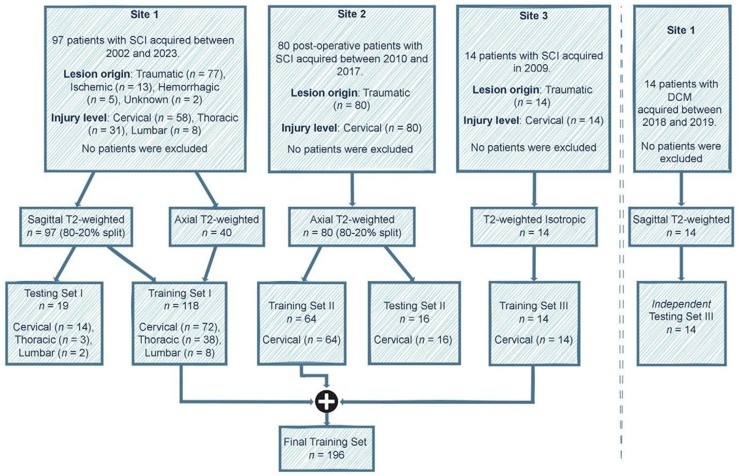
Figure 1: Study flowchart. The data included patient cohorts from three sites with heterogeneous image resolutions, orientations, and lesion etiologies. The validation set is included within the final training set. Models were evaluated independently on the test sets of site 1 and site 2, along with their evaluation on an external test set of patients with degenerative cervical myelopathy (DCM). See Table 1 for details on the MRI vendors and field strengths. SCI = spinal cord injury. [Figure 1 and its caption (11), CC-BY 4.0]
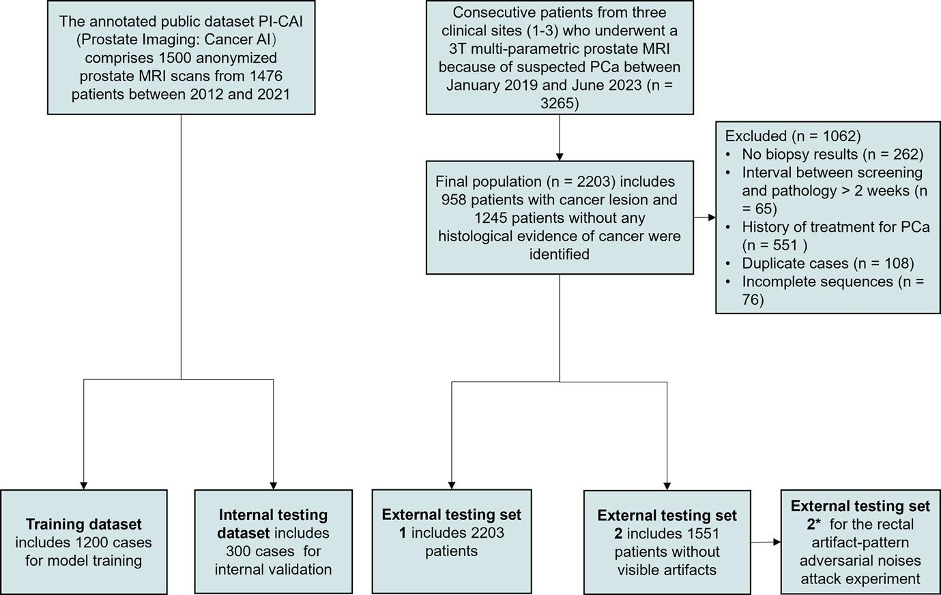
Figure 1: Diagram for inclusion of patients into the study. The PI-CAI public dataset was randomly divided in a 4:1 ratio for model training and internal testing. External testing set 1 assessed model performance in a clinical setting. External testing set 2 contained 1551 cases without visible artifacts. External testing set 2*, sharing the same patients as set 2, had subtle, invisible rectal artifact–like noises added to the images. External testing sets 2 and 2* were used to conduct a rectal artifact–pattern adversarial noise attack experiment to assess rectal artifact noise interference on the DL model. DL = deep learning, PCa = prostate cancer, PI-CAI = Prostate Imaging: Cancer AI. [Figure 1 and its caption (21), CC-BY 4.0]

Item 36 — Demographic and clinical characteristics of cases in each partition and dataset

Specify the demographic and clinical characteristics of cases in each partition and dataset. Identify sources of potential bias that may originate from differences in demographic or clinical characteristics, such as sex distribution, underrepresented racial or ethnic groups, phenotypic variations, or differences in treatment.
Explanation and Elaboration: Key characteristics include age, sex, race/ethnicity, and disease presence. Depending on the clinical context, additional relevant characteristics may include known risk factors, comorbidities, disease severity, genetic markers, laboratory test values, prior treatments, and socioeconomic indicators. These characteristics should be summarized using appropriate descriptive statistics (e.g. mean with standard deviation or median with interquartile ranges) and presented separately for each dataset. Tabular presentation (typically in Table 1) is standard and should include stratification by dataset.

Examples
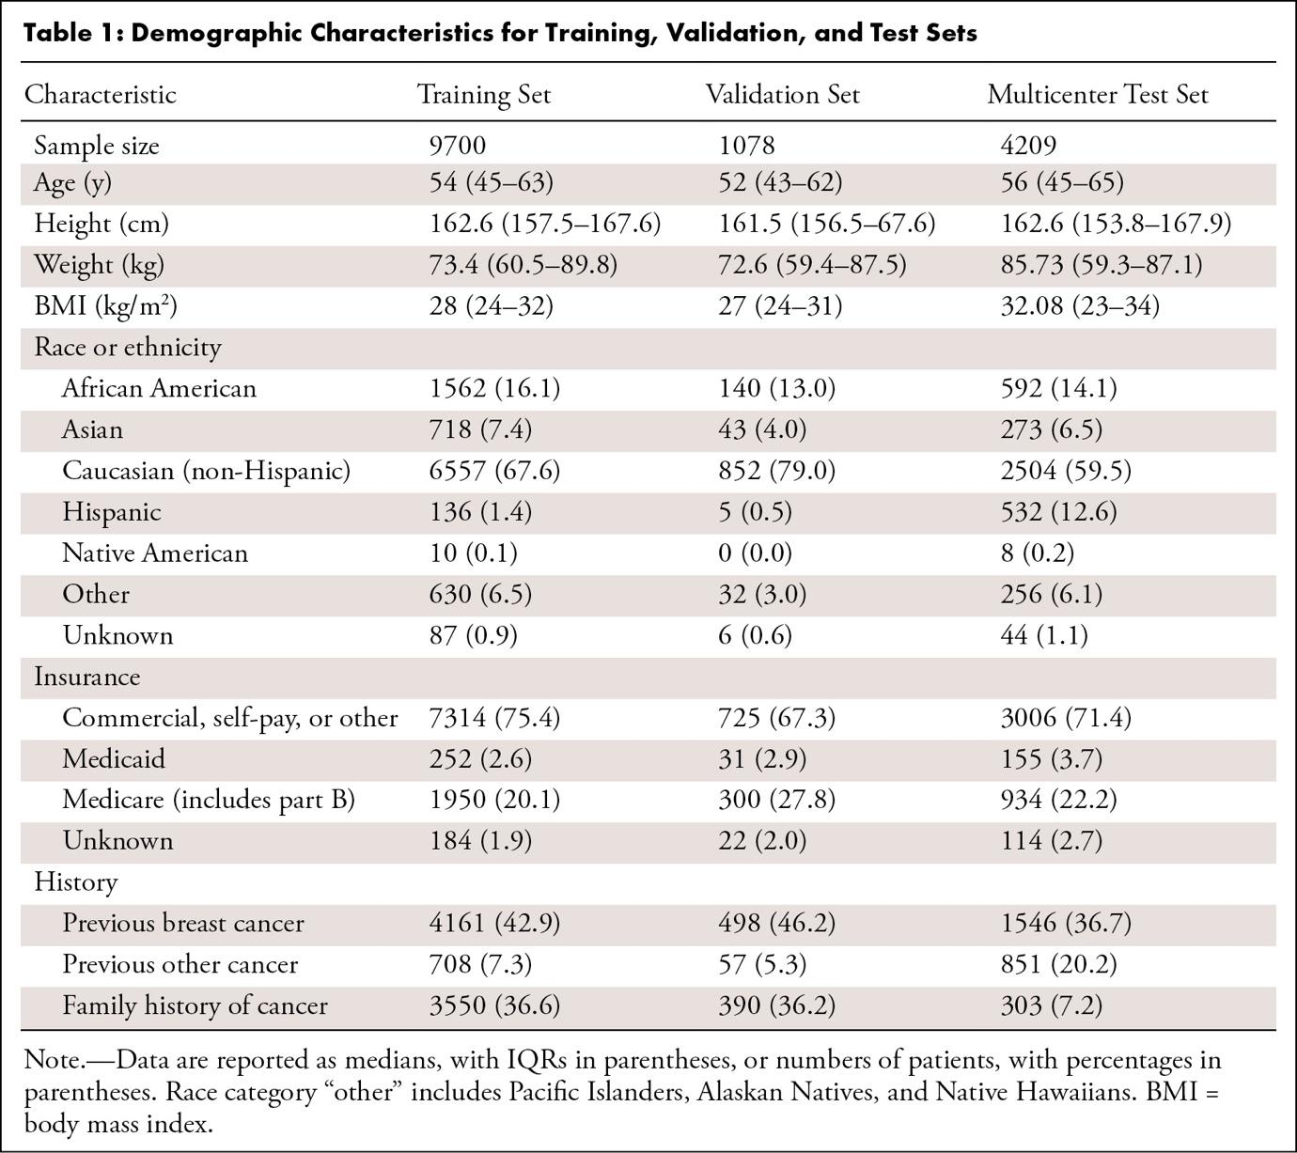
Table 1: Demographic Characteristics for Training, Validation, and Test Sets. [Table 1 and its caption (32), CC-BY 4.0]
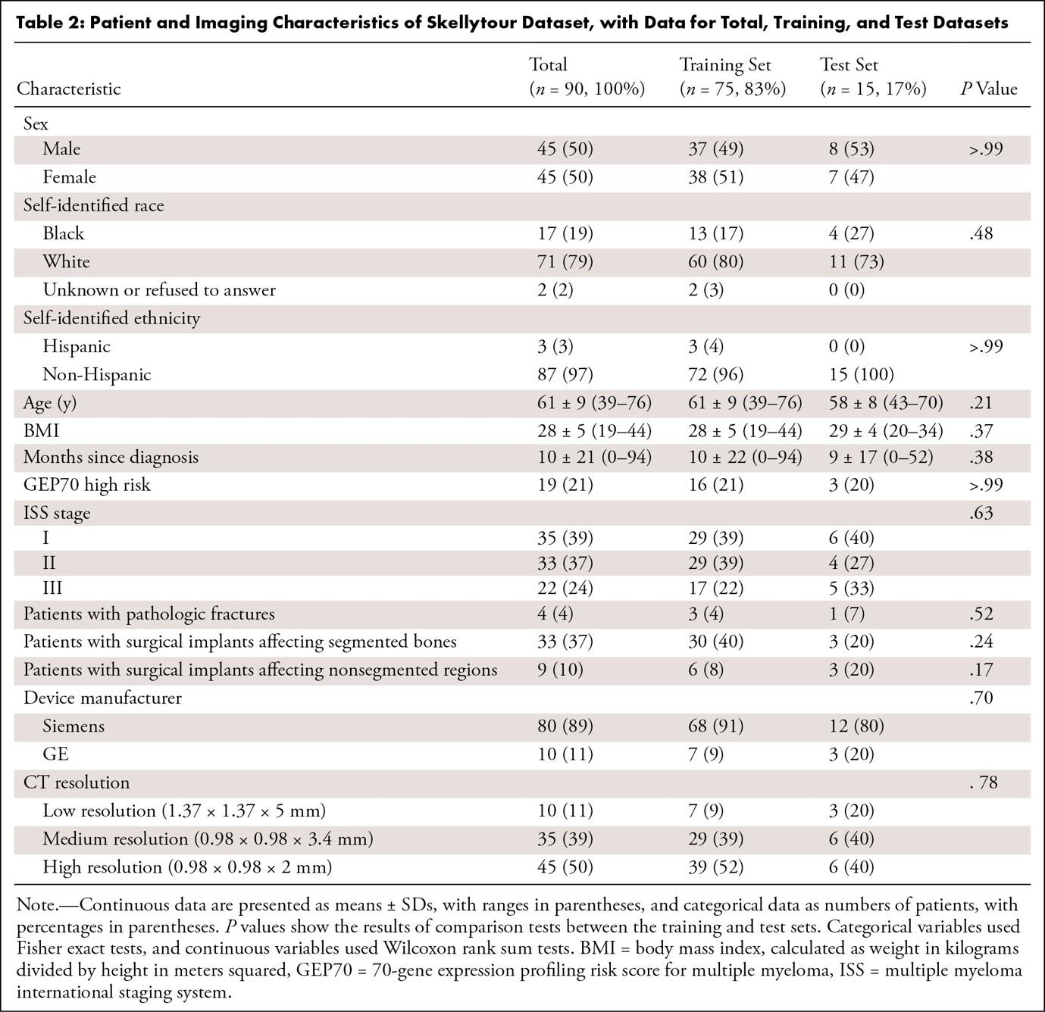
Table 2: Patient and Imaging Characteristics of Skellytour Dataset, with Data for Total, Training, and Test Datasets. [Table 2 and its caption (14), CC BY 4.0]

Item 37 — Performance metrics and measures of statistical uncertainty

Report the final model’s performance. Benchmark the performance of the AI model against the reference standard, such as histopathologic identification of disease or a panel of medical experts with an explicit method to resolve disagreements. State the performance metrics on all data partitions and datasets, including any demographic subgroups.
Explanation and Elaboration: Evaluation of performance metrics stratified across demographic subgroups is critical to identify potential biases and ensure equitable model performance. Uncertainty measures are particularly important for these stratified analyses, as some large apparent differences in performance may not be significant due to small size of subgroups.
Examples
The average DSC between the two expert readers was high. The DSC between the algorithm and Reader 1 was 0.68 (0.07 SD) and Reader 2 was 0.70 (0.07 SD), with no significant difference detected between the two distributions (p = 0.31, t-test). [Results (73), CC-BY 4.0]
The AUC of nomogram for predicting 6-month PFS in training set, validation set and testing set are 0.847 (0.737–0.957), 0.786 (0.566–1.000) and 0.864 (0.735–0.994), respectively. ... The AUC of nomogram for predicting 1-year OS in training set, validation set and testing set are 0.770 (0.635–0.906), 0.743 (0.479–1.000) and 0.818 (0.630–1.000), respectively. [Results (74), CC-BY 4.0]

Item 38 — Estimates of diagnostic performance and their precision

For classification tasks, include estimates of diagnostic accuracy and their measures of statistical uncertainty, such as 95% confidence intervals. Apply appropriate methodology such as receiver operating characteristic analysis and/or calibration curves. When the direct calculation of confidence intervals is not possible, report nonparametric estimates from bootstrap samples. State which variables were shown to be predictive of the response variable. Identify the subpopulation(s) for which the prediction model worked most and least effectively. If applicable, recognize the presence of class imbalance (uneven distribution across data classes within or between datasets) and provide appropriate metrics to reflect algorithm performance…
Explanation and Elaboration: Quantification of uncertainty facilitates the reader’s understanding of whether or not apparent differences in performance are significant. Raw confidence values associated with classifications produced by machine learning models are generally poor estimates of the probability that the classification is correct. Calibration maps model confidence values to calibrated probabilities so they better reflect the true likelihood that a prediction is correct (75,76). The predictive variables driving the model's performance should be explicitly stated, enabling readers to assess their clinical relevance. Subpopulation analyses are critical to identifying groups where the model performs well or poorly, ensuring transparency in its generalizability and fairness. Addressing class imbalance is particularly important in medical datasets, where uneven distributions can skew model performance (77).

Examples
The sensitivity per patient was estimated at 64.8% (3732 of 5760 readings) without AI aid and 75.2% (4331 of 5760 readings) with AI aid, with an AI effect estimated at +10.4% (95% CI: 6.9, 13.9; one-sided P < .001 for superiority). The specificity per patient was estimated at 90.6% (5217 of 5760 readings) without AI aid and 95.6% (5504 of 5760 readings) with AI aid, with an AI effect estimated at +5.0% (95% CI: +2.0, +8.0; one-sided P = .001 for noninferiority and one-sided P = .001 for superiority). Therefore, the primary analysis was successful, and the superiority of specificity per patient with AI aid was demonstrated (hierarchical test). Other metrics for all readers are compared in Table 2 by using two-sided tests. Overall, the reading time was 6.3 seconds shorter (95% CI: –12.5, –0.1; P = .046) with AI aid than without… Planned sensitivity analyses did not change the point estimate and tended to reduce the width of the CI of the sensitivity per patient gain, up to 26% for the linear mixed-effects model compared with the primary analysis, meaning that the primary analysis is more conservative (Table E3 [online]). A post hoc sensitivity analysis removing the outlier (a rheumatologist with extremely low diagnostic performances) did not change the conclusions: There was a 9.5% (95% CI: +6.4, +12.5; one-sided P < .001 for superiority) gain of sensitivity per patient and 4.0% (95% CI: +1.8, +6.2; one-sided P < .001 for superiority) gain of specificity per patient. [Results (78), CC BY 4.0.]
The overall accuracy in generating differential diagnoses improved with increased temperature settings in both GPT-4V (T1, 49% [93 of 190 cases]; T0.5, 45% [86 of 190 cases]; T0, 41% [78 of 190 cases]) and Gemini Pro Vision (T1, 39% [74 of 190 cases]; T0.5, 36% [69 of 190 cases]; T0, 29% [55 of 190 cases]), although there was no evidence of a statistically significant difference (T1 vs T0: 49% vs 41% [P = .12] for GPT-4V and 39% vs 29% [P = .04] for Gemini Pro Vision). The overall accuracy of radiologists was 61% (115 of 190 cases), which was higher than that of Gemini Pro Vision at T1 (39% [74 of 190 cases], P < .001). There was no evidence of a statistically significant difference in overall accuracy between radiologists and GPT-4V at T1 (49% [93 of 190 cases]) after Bonferroni adjustment (P = .02). No evidence of a statistically significant difference in accuracy was observed at T1 between GPT-4V (49% [93 of 190 cases]) and Gemini Pro Vision (39% [74 of 190 cases], P = .05). [Results (79), © RSNA 2024]

Item 39 — Failure analysis of incorrect results

Provide information to help understand incorrect results. If the task entails classification into two or more categories, provide a confusion matrix that shows tallies for predicted versus actual categories. Consider presenting examples of incorrectly classified cases to help readers better understand the strengths and limitations of the algorithm. Provide sufficient detail to frame incorrect results in the appropriate medical context.
Explanation and Elaboration: The goal of the failure analysis discussion is to provide the reader with some understanding of what types of errors the model is likely to make and, to the extent possible, why it may make those errors. This promotes understanding of the risks of the present model and helps to identify areas for improvement for future models. Expected outcomes for different types of errors (e.g false positive vs false negative) are often different. For each type of error, the clinical implications of that error occurring in the deployed model should be discussed.

Examples
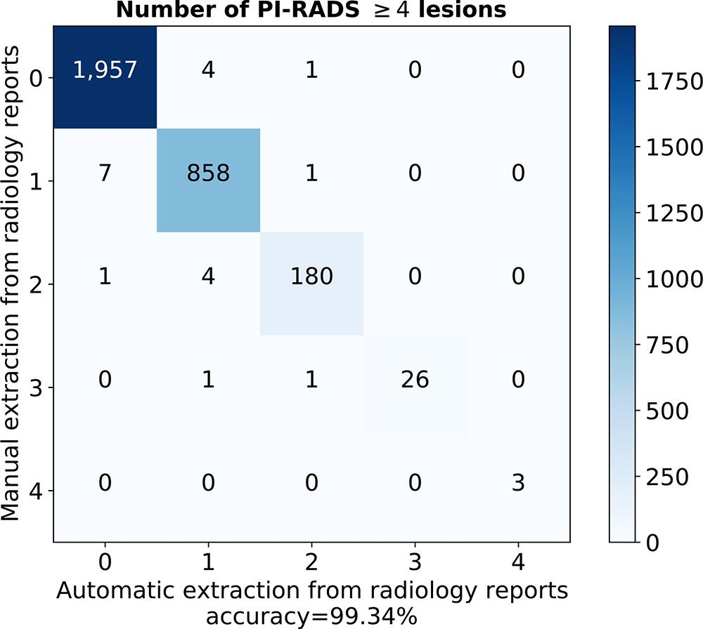
Figure 2: Accuracy of natural language processing score extraction algorithm, as depicted by the confusion matrix for number of clinically significant findings in a radiology report. Evaluated on the manually labeled development dataset. PI-RADS = Prostate Imaging and Reporting Data System. [Figure 2 and its caption (80), CC BY 4.0]
The few failed detections on long-axis test images were due to incorrect imaging planning, unusual LV shapes, or poor image quality. Examples and a discussion of failed detections on long-axis images can be found in Figure E2 (supplement)
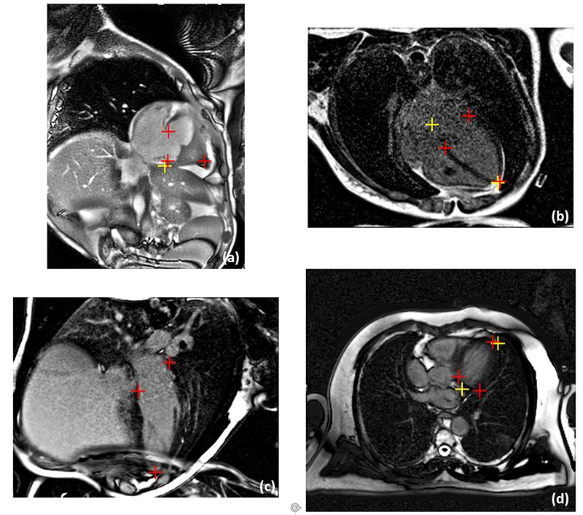
Figure E2: Examples of failed detection for LAX views. (a) This CH2 cine image contains unusual anatomy, due to congenital heart abnormality of this patient. Model missed two landmarks on this image. (b) This LGE image had very low signal-noise-ratio. The model correctly detected apical point but missed other landmarks. (c) An LGE image had severe aliasing artifacts, causing models to miss all three landmarks. (d) The acquisition plane of this CH4 LGE image was imperfectly placed, causing the model to miss landmarks. Red: manual landmarks; Yellow: model landmarks. [Results, Figure E2 and its caption (81), CC BY 4.0]

Item 40 — Study limitations

Identify the study’s limitations, including those involving the study’s methods, materials, biases, statistical uncertainty, unexpected results, and generalizability. This discussion should follow succinct summarization of the results with appropriate context and explanation of how the current work advances our knowledge and the state of the art.
Explanation and Elaboration: Think broadly about the potential sources of bias and error in your investigation. What are the assumptions inherent in the methods, how likely are those assumptions to be incorrect, and what would the impact be if they were? Intelligent discussion of the limitations that are potentially unique to a study adds greatly to a manuscript; pro forma listing of the limitations that are inherent and common to all investigations in a field adds little.

Examples
While our AI system shows potential to impact LCS worldwide, the studies performed and the system both have limitations to consider. As in other recent studies, although realistic environments were used, the studies were retrospective on an enriched dataset. Similarly, this study did not include the full breadth of potential data that a radiologist may access in the electronic health record, such as smoking history. Any impact of having such variables available will need to be evaluated in future work. As our analysis principally focused on the performance of experienced radiologists on challenging cases, the impact of AI assistance on less experienced radiologists also needs to be examined in follow-up work. As positive cancer cases are more difficult to obtain, a total of 50 patients outside of NLST that were positive for cancer were used for evaluation. These cases were from different patient populations and involved selecting the earliest study within 2 years prior to biopsy. Subject to study feasibility, future studies could improve upon these limitations of retrospective enriched studies. [Discussion (39), CC BY 4.0]
Some limitations of the present study must be acknowledged. First, manual delineation of the brainstem and ventricular regions was performed by a single rater, although with more than 30 years of experience in the field of neuroradiology. Second, PD and PSP cases were not pathologically confirmed. Moreover, we considered only patients with PSP–Richardson syndrome, and further studies are needed to investigate the robustness and usefulness of our approach in other clinical subtypes, such as PSP parkinsonism, and/or considering patients at early disease stages. Third, during the models’ training phase, we did not adopt early stopping criteria and cross-validation. Although this can lead to overfitting issues, the optimal segmentation performance displayed by DL-based models in the independent external test datasets indicates their generalizability on new MR images. Fourth, a min-max intensity normalization method was used to transform the image intensity range of MR images used as input to DL-based models. While this approach is commonly used to transform the intensity histogram to a 0–1 range without affecting the image itself, it may be influenced by outliers in the raw intensity values. Finally, although our results showed clear-cut differences between patients with PD and patients with PSP in MP, MRPI, and MRPI 2.0, it is important to highlight that these indices are computed based on brainstem and ventricular morphologic features that are significantly correlated. A high degree of collinearity may increase the risk of observing statistically significant results by chance and make the determination of the individual contribution of each brain region to the indices challenging. [Discussion (36), CC BY 4.0]

Item 41 — Implications for practice, including intended use and/or clinical role

Describe the implications for practice, including the intended use and possible clinical role of the AI model. Describe the key impact the work may have on the field, including changes from current practice. Envision the next steps that one might take to build upon the results. Discuss any issues that would impede successful translation of the model into practice.
Explanation and Elaboration: It is essential to clearly define the model’s intended use to ensure a clear understanding of its role. Describe how the model may improve clinical practice, as well as potential unintended consequences, risks, new burdens imposed by working with and supervising the AI and new or additional requirements for successful deployment. If there are unsolved problems that stand as barriers to clinical implementation, identify these as areas where additional research is needed.

Examples
Using model diagnosis and interpretable attention maps improved radiologists’ diagnostic performance compared with the unassisted group. The attention maps aided radiologists in assessing the model’s diagnosis importance and accurately locating lesions, reducing missed diagnoses…. This approach is especially valuable in regions with a specialist shortage. [Discussion (7), CC BY 4.0]
One major barrier to the widespread clinical deployment of machine learning models is the need for improved generalization. Models must maintain high levels of performance accuracy on data from diverse sources encompassing heterogeneous populations and differing technical parameters. To address this, we employed a semi-supervised learning paradigm to detect and segment intracranial hemorrhage on head CT images using a broad complement of both labeled and unlabeled data to improve model generalization capability. [Discussion (62), CC BY 4.0]
In conclusion, replacing one or both radiologists in double-read mammography screening with AI seems feasible, but there were important differences in accuracy and workload depending on the deployment site in the workflow. A triage-based approach was found to have the best outcome across all performance metrics. However, as it is not possible to replace both readers because of current national guidelines, replacing the first reader with AI represents a feasible solution for implementation. Prospective trials are warranted to validate these scenarios, with particular focus on the effect of AI-integrated screening on clinically relevant outcomes, as well as the impact of replacing either the first or second reader because of their differing experience and accuracy. [Discussion (22), CC BY 4.0]

Item 42 — Provide a reference to the full study protocol or to additional technical details

State where readers can access the full study protocol or additional technical details if this description exceeds the journal’s word limit. For clinical trials, include reference to the study protocol text referenced in item 34. For experimental or preclinical studies, include reference to details of the AI methodology, if not fully documented in the manuscript or supplemental material. This information can help readers evaluate the validity of the study and can help researchers who want to replicate the study.
Explanation and Elaboration: Comprehensive, detailed description of methodology sufficient to enable reproduction of the work is the foundation of science. Unfortunately, the amount of text required to fully relate AI methods and complex clinical trials are often in conflict with the manuscript length limits enforced by journals. In the frequent case where it is not possible to fit all the details of the methods into the main article, this information should be provided through other channels and referenced in the article. Clinical trial studies are best referenced to their registries. Source code for model training may be shared through reference to repositories, such as services enabling version control. Information provided through reference to external sources like these should be expected to remain available for at least 5–10 years; in general personal or lab websites do not mean this durability requirement. Other methodological material may be included as appendices or supplements to the manuscript. Through completely describing their methods authors provide a roadmap for others to fully understand, replicate, and build upon their work, fostering credibility and advancement in the field.

Examples
The study is registered at www.chictr.org.cn (registration no. ChiCTR2300069832). [Material and methods (21), CC BY 4.0]
The RadImageNet pretrained models and codes can be accessed at https://github.com/BMEII-AI/RadImageNet. [Material and methods (5), CC BY 4.0]
Specific details on the model architecture are described in Appendix E4 (supplement). [Material and methods (81), CC BY 4.0]

Item 43 — Statement about the availability of software, trained model, and/or data

State where the reader can access the software, model, and/or data associated with the study, including conditions under which these resources can be accessed. Describe the algorithms and software in sufficient detail to allow replication of the study. Authors should deposit all computer code used for modelling and/or data analysis into a publicly accessible repository.
Explanation and Elaboration: Availability of the software, trained model, and data fosters reproducibility and accelerates scientific progress. Experience has shown that resources that are “available on request” frequently turn out not to be available, so open sharing through deposits of resources into established repositories is strongly preferred. For studies where sharing is restricted due to privacy or legal concerns, authors should clarify these limitations and, if possible, offer alternative ways for external researchers to collaborate or gain access to relevant resources.

Examples
The code for our scripts is made available, and a practical guide is provided (https://github.com/BastienLeGuellec/RadioVicuna). [Discussion (24) CC BY 4.0.]
The ready-to-use online tool is available at https://totalsegmentator.com; the model, at https://github.com/wasserth/TotalSegmentator; and the dataset, at http://zenodo.org/records/14710732. [Conclusion (37), © RSNA 2025]
Training procedures are described in Appendix. Our code is available on GitHub (https://github.com/xiawei999000/WISDOM). [Materials and methods (82), CC BY 4.0]

Item 44 — Sources of funding and other support; role of funders

Specify the sources of funding and other support and the exact role of the funders in performing the study. Indicate whether the authors had independence in each phase of the study.
Explanation and Elaboration: Authors should describe how funders contributed, whether through financial resources, in-kind, materials, or logistical support, and detail any other involvement in the study. Additionally, authors should indicate whether they retained full independence in conducting the study, free from any influence or control by the funders, particularly in areas critical to research integrity like data interpretation and publication of results. Any writing performed by parties not listed as authors should be disclosed, particularly if they are sponsors or paid by sponsors. This transparency allows readers to assess potential biases or conflicts of interests that may arise from funding sources.

Examples
Supported by the Innovation Fund by the Region of Southern Denmark (grant 10240300). [Author contributions (22), CC-BY 4.0]
This study was funded by the German Federal Ministry of Education and Research (grant no. 01EA1709) within the framework of the Junior Research Group for Personalized Nutrition & eHealth (PeNut) of the enable Competence Cluster of Nutrition Research. The analysis was part of the project IMaGENE funded by German Federal Ministry of Education and Research (grant no. 16DKWN075). Further, the present work was supported by the German Research Foundation (project no. 450799851 and project no. 455422993/FOR 5298-iMAGO-P1). D.R. is supported by the German Federal Ministry of Education and Research, the European Research Council, and the Alexander von Humboldt Foundation through grants to institution. [Author contributions (40), CC-BY 4.0]

References

1. Venkatesh K, Santomartino SM, Sulam J, Yi PH. Code and Data Sharing Practices in the Radiology Artificial Intelligence Literature: A Meta-Research Study. Radiol Artif Intell. 2022 Sep;4(5):e220081.
2. Mongan J, Moy L, Kahn CE. Checklist for artificial intelligence in medical imaging (CLAIM): A guide for authors and reviewers. Radiol Artif Intell. 2020 Mar 25;2(2):e200029.
3. Tejani AS, Klontzas ME, Gatti AA, Mongan JT, Moy L, Park SH, et al. Checklist for artificial intelligence in medical imaging (CLAIM): 2024 update. Radiol Artif Intell. 2024 Jul;6(4):e240300.
4. Kocak B, Keles A, Akinci D’Antonoli T. Self-reporting with checklists in artificial intelligence research on medical imaging: a systematic review based on citations of CLAIM. Eur Radiol. 2024 Apr;34(4):2805–15.
5. Mei X, Liu Z, Robson PM, Marinelli B, Huang M, Doshi A, et al. Radimagenet: an open radiologic deep learning research dataset for effective transfer learning. Radiol Artif Intell. 2022 Sep;4(5):e210315.
6. Hickman SE, Payne NR, Black RT, Huang Y, Priest AN, Hudson S, et al. Deep Learning Algorithms for Breast Cancer Detection in a UK Screening Cohort: As Stand-alone Readers and Combined with Human Readers. Radiology. 2024 Nov;313(2):e233147.
7. Dai L, Lei J, Ma F, Sun Z, Du H, Zhang H, et al. Boosting Deep Learning for Interpretable Brain MRI Lesion Detection through the Integration of Radiology Report Information. Radiol Artif Intell. 2024 Nov;6(6):e230520.
8. Barros V, Tlusty T, Barkan E, Hexter E, Gruen D, Guindy M, et al. Virtual Biopsy by Using Artificial Intelligence-based Multimodal Modeling of Binational Mammography Data. Radiology. 2023 Mar;306(3):e220027.
9. Ueda D, Katayama Y, Yamamoto A, Ichinose T, Arima H, Watanabe Y, et al. Deep Learning-based Angiogram Generation Model for Cerebral Angiography without Misregistration Artifacts. Radiology. 2021 Jun;299(3):675–81.
10. Archetti D, Venkatraghavan V, Weiss B, Bourgeat P, Auer T, Vidnyánszky Z, et al. A machine learning model to harmonize volumetric brain MRI data for quantitative neuroradiologic assessment of alzheimer disease. Radiol Artif Intell. 2025 Jan;7(1):e240030.
11. Naga Karthik E, Valošek J, Smith AC, Pfyffer D, Schading-Sassenhausen S, Farner L, et al. SCIseg: Automatic Segmentation of Intramedullary Lesions in Spinal Cord Injury on T2-weighted MRI Scans. Radiol Artif Intell. 2025 Jan;7(1):e240005.
12. Obreja B, Bosma J, Venkadesh KV, Saghir Z, Prokop M, Jacobs C. Characterizing the impact of training data on generalizability: application in deep learning to estimate lung nodule malignancy risk. Radiol Artif Intell. 2025 Nov;7(6):e240636.
13. Wachinger C, Renger B, Späth C, Makowski MR. Body Charts from CT Segmentations across the Adult Lifespan: Large-scale Cross-sectional and Longitudinal Analyses. Radiol Artif Intell. 2026 Mar;8(2):e250506.
14. Mann DC, Rutherford MW, Farmer P, Eichhorn JM, Palot Manzil FF, Wardell CP. Evaluating Skellytour for Automated Skeleton Segmentation from Whole-Body CT Images. Radiol Artif Intell. 2025 Mar;7(2):e240050.
15. Demirel OB, Ghanbari F, Hoeger CW, Tsao CW, Carty A, Ngo LH, et al. Late gadolinium enhancement cardiovascular magnetic resonance with generative artificial intelligence. J Cardiovasc Magn Reson. 2024 Nov 28;27(1):101127.
16. Papachristou P, Söderholm M, Pallon J, Taloyan M, Polesie S, Paoli J, et al. Evaluation of an artificial intelligence-based decision support for the detection of cutaneous melanoma in primary care: a prospective real-life clinical trial. Br J Dermatol. 2024 Jun 20;191(1):125–33.
17. Lee J, Park KM, Park S. Interpretable machine learning for prediction of clinical outcomes in acute ischemic stroke. Front Neurol. 2023 Sep 7;14:1234046.
18. Karkehabadi H, Khoshbin E, Ghasemi N, Mahavi A, Mohammad-Rahimi H, Sadr S. Deep learning for determining the difficulty of endodontic treatment: a pilot study. BMC Oral Health. 2024 May 17;24(1):574.
19. Xue C, Kowshik SS, Lteif D, Puducheri S, Jasodanand VH, Zhou OT, et al. AI-based differential diagnosis of dementia etiologies on multimodal data. Nat Med. 2024 Oct;30(10):2977–89.
20. Sau A, Pastika L, Sieliwonczyk E, Patlatzoglou K, Ribeiro AH, McGurk KA, et al. Artificial intelligence-enabled electrocardiogram for mortality and cardiovascular risk estimation: a model development and validation study. Lancet Digit Health. 2024 Nov;6(11):e791–802.
21. Hu L, Guo X, Zhou D, Wang Z, Dai L, Li L, et al. Development and Validation of a Deep Learning Model to Reduce the Interference of Rectal Artifacts in MRI-based Prostate Cancer Diagnosis. Radiol Artif Intell. 2024 Mar;6(2):e230362.
22. Elhakim MT, Stougaard SW, Graumann O, Nielsen M, Gerke O, Larsen LB, et al. AI-integrated Screening to Replace Double Reading of Mammograms: A Population-wide Accuracy and Feasibility Study. Radiol Artif Intell. 2024 Nov;6(6):e230529.
23. Pedemonte S, Tsue T, Mombourquette B, Truong Vu YN, Matthews T, Morales Hoil R, et al. A semiautonomous deep learning system to reduce false positives in screening mammography. Radiol Artif Intell. 2024 May;6(3):e230033.
24. Le Guellec B, Lefèvre A, Geay C, Shorten L, Bruge C, Hacein-Bey L, et al. Performance of an Open-Source Large Language Model in Extracting Information from Free-Text Radiology Reports. Radiol Artif Intell. 2024 Jul;6(4):e230364.
25. Xue H, Davies RH, Brown LAE, Knott KD, Kotecha T, Fontana M, et al. Automated Inline Analysis of Myocardial Perfusion MRI with Deep Learning. Radiol Artif Intell. 2020 Oct 21;2(6):e200009.
26. Sforazzini F, Salome P, Moustafa M, Zhou C, Schwager C, Rein K, et al. Deep Learning-based Automatic Lung Segmentation on Multiresolution CT Scans from Healthy and Fibrotic Lungs in Mice. Radiol Artif Intell. 2022 Mar;4(2):e210095.
27. Tiyarattanachai T, Apiparakoon T, Marukatat S, Sukcharoen S, Geratikornsupuk N, Anukulkarnkusol N, et al. Development and validation of artificial intelligence to detect and diagnose liver lesions from ultrasound images. PLoS ONE. 2021 Jun 8;16(6):e0252882.
28. Li H, Chai L, Pu H, Yin L-L, Li M, Zhang X, et al. T2WI-based MRI radiomics for the prediction of preoperative extranodal extension and prognosis in resectable rectal cancer. Insights Imaging. 2024 Feb 27;15(1):57.
29. Johnson AEW, Pollard TJ, Berkowitz SJ, Greenbaum NR, Lungren MP, Deng C-Y, et al. MIMIC-CXR, a de-identified publicly available database of chest radiographs with free-text reports. Sci Data. 2019 Dec 12;6(1):317.
30. Tsai EB, Simpson S, Lungren MP, Hershman M, Roshkovan L, Colak E, et al. The RSNA International COVID-19 Open Radiology Database (RICORD). Radiology. 2021 Apr;299(1):E204–13.
31. Eijgelaar RS, Visser M, Müller DMJ, Barkhof F, Vrenken H, van Herk M, et al. Robust Deep Learning-based Segmentation of Glioblastoma on Routine Clinical MRI Scans Using Sparsified Training. Radiol Artif Intell. 2020 Sep 30;2(5):e190103.
32. Ezeana CF, He T, Patel TA, Kaklamani V, Elmi M, Brigmon E, et al. A Deep Learning Decision Support Tool to Improve Risk Stratification and Reduce Unnecessary Biopsies in BI-RADS 4 Mammograms. Radiology: Artificial Intelligence. 2023 Aug 9;
33. Fields BKK, Calabrese E, Mongan J, Cha S, Hess CP, Sugrue LP, et al. The University of California San Francisco Adult Longitudinal Post-Treatment Diffuse Glioma MRI Dataset. Radiol Artif Intell. 2024 Jul;6(4):e230182.
34. Bartnik K, Bartczak T, Krzyziński M, Korzeniowski K, Lamparski K, Węgrzyn P, et al. WAW-TACE: A Hepatocellular Carcinoma Multiphase CT Dataset with Segmentations, Radiomics Features, and Clinical Data. Radiol Artif Intell. 2024 Nov;6(6):e240296.
35. Gonzales RA, Seemann F, Lamy J, Mojibian H, Atar D, Erlinge D, et al. MVnet: automated time-resolved tracking of the mitral valve plane in CMR long-axis cine images with residual neural networks: a multi-center, multi-vendor study. J Cardiovasc Magn Reson. 2021 Dec 2;23(1):137.
36. Nigro S, Filardi M, Tafuri B, Nicolardi M, De Blasi R, Giugno A, et al. Deep Learning-based Approach for Brainstem and Ventricular MR Planimetry: Application in Patients with Progressive Supranuclear Palsy. Radiol Artif Intell. 2024 May;6(3):e230151.
37. Akinci D’Antonoli T, Berger LK, Indrakanti AK, Vishwanathan N, Weiss J, Jung M, et al. TotalSegmentator MRI: Robust Sequence-independent Segmentation of Multiple Anatomic Structures in MRI. Radiology. 2025 Feb;314(2):e241613.
38. Huhtanen HJ, Nyman MJ, Karlsson A, Hirvonen J. Machine Learning and Deep Learning Models for Automated Protocoling of Emergency Brain MRI Using Text from Clinical Referrals. Radiol Artif Intell. 2025 Feb 19;e230620.
39. Kiraly AP, Cunningham CA, Najafi R, Nabulsi Z, Yang J, Lau C, et al. Assistive AI in lung cancer screening: A retrospective multinational study in the united states and japan. Radiol Artif Intell. 2024 May;6(3):e230079.
40. Somasundaram A, Wu M, Reik A, Rupp S, Han J, Naebauer S, et al. Evaluating Sex-specific Differences in Abdominal Fat Volume and Proton Density Fat Fraction at MRI Using Automated nnU-Net-based Segmentation. Radiol Artif Intell. 2024 Jul;6(4):e230471.
41. Koo TK, Li MY. A guideline of selecting and reporting intraclass correlation coefficients for reliability research. J Chiropr Med. 2016 Jun;15(2):155–63.
42. Alabed S, Alandejani F, Dwivedi K, Karunasaagarar K, Sharkey M, Garg P, et al. Validation of artificial intelligence cardiac MRI measurements: relationship to heart catheterization and mortality prediction. Radiology. 2022 Oct;305(1):68–79.
43. Kay FU, Canan A, Kukkar V, Hulsey K, Scanio A, Fan C, et al. Diagnostic Accuracy of On-Premise Automated Coronary CT Angiography Analysis Based on Coronary Artery Disease Reporting and Data System 2.0. Radiology. 2025 May;315(2):e242087.
44. Jiang X, Zhao H, Saldanha OL, Nebelung S, Kuhl C, Amygdalos I, et al. An MRI deep learning model predicts outcome in rectal cancer. Radiology. 2023 Jun;307(5):e222223.
45. Locherer M, Bonenberger C, Ertel W, Hadaschik B, Stumm K, Schneider M, et al. Multi-label semantic segmentation of magnetic resonance images of the prostate gland. Discov Artif Intell. 2024 Oct 2;4(1):66.
46. Shoshan Y, Bakalo R, Gilboa-Solomon F, Ratner V, Barkan E, Ozery-Flato M, et al. Artificial Intelligence for Reducing Workload in Breast Cancer Screening with Digital Breast Tomosynthesis. Radiology. 2022 Apr;303(1):69–77.
47. Gupta A, Chauhan R, G S, Shreekumar A. Improving sepsis prediction in intensive care with SepsisAI: A clinical decision support system with a focus on minimizing false alarms. PLOS Digit Health. 2024 Aug 12;3(8):e0000569.
48. Hirsch L, Huang Y, Luo S, Rossi Saccarelli C, Lo Gullo R, Daimiel Naranjo I, et al. Radiologist-Level Performance by Using Deep Learning for Segmentation of Breast Cancers on MRI Scans. Radiol Artif Intell. 2022 Jan;4(1):e200231.
49. Akinci D’Antonoli T, Todea R-A, Leu N, Datta AN, Stieltjes B, Pruefer F, et al. Development and evaluation of deep learning models for automated estimation of myelin maturation using pediatric brain MRI scans. Radiol Artif Intell. 2023 Sep;5(5):e220292.
50. Drozdov I, Dixon R, Szubert B, Dunn J, Green D, Hall N, et al. An artificial neural network for nasogastric tube position decision support. Radiol Artif Intell. 2023 Mar;5(2):e220165.
51. Guo R, El-Rewaidy H, Assana S, Cai X, Amyar A, Chow K, et al. Accelerated cardiac T1 mapping in four heartbeats with inline MyoMapNet: a deep learning-based T1 estimation approach. J Cardiovasc Magn Reson. 2022 Jan 6;24(1):6.
52. El-Rewaidy H, Fahmy AS, Pashakhanloo F, Cai X, Kucukseymen S, Csecs I, et al. Multi-domain convolutional neural network (MD-CNN) for radial reconstruction of dynamic cardiac MRI. Magn Reson Med. 2021 Mar;85(3):1195–208.
53. Narkhede MV, Bartakke PP, Sutaone MS. A review on weight initialization strategies for neural networks. Artif Intell Rev. 2021 Jun 28;
54. Zormpas-Petridis K, Tunariu N, Curcean A, Messiou C, Curcean S, Collins DJ, et al. Accelerating Whole-Body Diffusion-weighted MRI with Deep Learning-based Denoising Image Filters. Radiol Artif Intell. 2021 Sep;3(5):e200279.
55. Almeida JG de, Rodrigues NM, Castro Verde AS, Mascarenhas Gaivão A, Bilreiro C, Santiago I, et al. Impact of Scanner Manufacturer, Endorectal Coil Use, and Clinical Variables on Deep Learning-assisted Prostate Cancer Classification Using Multiparametric MRI. Radiol Artif Intell. 2025 Jan 22;e230555.
56. Zhang J, Cui Z, Shi Z, Jiang Y, Zhang Z, Dai X, et al. A robust and efficient AI assistant for breast tumor segmentation from DCE-MRI via a spatial-temporal framework. Patterns (N Y). 2023 Sep 8;4(9):100826.
57. Guo J, Goyal M, Xi Y, Hinojosa L, Haddad G, Albayrak E, et al. Style Transfer-assisted Deep Learning Method for Kidney Segmentation at Multiphase MRI. Radiol Artif Intell. 2023 Nov;5(6):e230043.
58. Mahajan P, Uddin S, Hajati F, Moni MA. Ensemble learning for disease prediction: A review. Healthcare (Basel). 2023 Jun 20;11(12).
59. Mairhörmann B, Castelblanco A, Häfner F, Koliogiannis V, Haist L, Winter D, et al. Automated MRI lung segmentation and 3D morphologic features for quantification of neonatal lung disease. Radiol Artif Intell. 2023 Nov;5(6):e220239.
60. Qummar S, Khan FG, Shah S, Khan A, Shamshirband S, Rehman ZU, et al. A deep learning ensemble approach for diabetic retinopathy detection. IEEE Access. 2019;7:150530–9.
61. Primakov SP, Ibrahim A, van Timmeren JE, Wu G, Keek SA, Beuque M, et al. Automated detection and segmentation of non-small cell lung cancer computed tomography images. Nat Commun. 2022 Jun 14;13(1):3423.
62. Lin E, Yuh EL. Semi-supervised Learning for Generalizable Intracranial Hemorrhage Detection and Segmentation. Radiol Artif Intell. 2024 May;6(3):e230077.
63. Xu D, Sui L, Zhang C, Xiong J, Wang VY, Zhou Y, et al. The clinical value of artificial intelligence in assisting junior radiologists in thyroid ultrasound: a multicenter prospective study from real clinical practice. BMC Med. 2024 Jul 12;22(1):293.
64. Wiklund P, Medson K. Incidental pulmonary embolism in abdominal CT: detection rate and characteristics with artificial intelligence. Radiol Adv. 2024 May 14;1(1).
65. Glocker B, Jones C, Roschewitz M, Winzeck S. Risk of bias in chest radiography deep learning foundation models. Radiol Artif Intell. 2023 Nov;5(6):e230060.
66. Polat DS, Nguyen S, Karbasi P, Hulsey K, Cobanoglu MC, Wang L, et al. Machine Learning Prediction of Lymph Node Metastasis in Breast Cancer: Performance of a Multi-institutional MRI-based 4D Convolutional Neural Network. Radiol Imaging Cancer. 2024 May;6(3):e230107.
67. Klontzas ME, Kalarakis G, Koltsakis E, Papathomas T, Karantanas AH, Tzortzakakis A. Convolutional neural networks for the differentiation between benign and malignant renal tumors with a multicenter international computed tomography dataset. Insights Imaging. 2024 Jan 25;15(1):26.
68. Guerra A, Orton MR, Wang H, Konidari M, Maes K, Papanikolaou NK, et al. Clinical application of machine learning models in patients with prostate cancer before prostatectomy. Cancer Imaging. 2024 Feb 8;24(1):24.
69. Kitamura FC, Prevedello LM, Colak E, Halabi SS, Lungren MP, Ball RL, et al. Lessons Learned in Building Expertly Annotated Multi-Institution Datasets and Hosting the RSNA AI Challenges. Radiol Artif Intell. 2024 May;6(3):e230227.
70. Fahmy AS, Rowin EJ, Arafati A, Al-Otaibi T, Maron MS, Nezafat R. Radiomics and deep learning for myocardial scar screening in hypertrophic cardiomyopathy. J Cardiovasc Magn Reson. 2022 Jun 27;24(1):40.
71. Teneggi J, Yi PH, Sulam J. Examination-level Supervision for Deep Learning–based Intracranial Hemorrhage Detection at Head CT. Radiology: Artificial Intelligence. 2023 Dec 20;
72. Dembrower K, Crippa A, Colón E, Eklund M, Strand F, ScreenTrustCAD Trial Consortium. Artificial intelligence for breast cancer detection in screening mammography in Sweden: a prospective, population-based, paired-reader, non-inferiority study. Lancet Digit Health. 2023 Oct;5(10):e703–11.
73. Trebeschi S, van Griethuysen JJM, Lambregts DMJ, Lahaye MJ, Parmar C, Bakers FCH, et al. Deep Learning for Fully-Automated Localization and Segmentation of Rectal Cancer on Multiparametric MR. Sci Rep. 2017 Jul 13;7(1):5301.
74. Lu W, Wu G, Miao X, Ma J, Wang Y, Xu H, et al. The radiomics nomogram predicts the prognosis of pancreatic cancer patients with hepatic metastasis after chemoimmunotherapy. Cancer Immunol Immunother. 2024 Mar 30;73(5):87.
75. Van Calster B, McLernon DJ, van Smeden M, Wynants L, Steyerberg EW, Topic Group ‘Evaluating diagnostic tests and prediction models’ of the STRATOS initiative. Calibration: the Achilles heel of predictive analytics. BMC Med. 2019 Dec 16;17(1):230.
76. Makimoto K. Why Calibration Matters More Than Accuracy in Clinical AI [Internet]. [cited 2026 Feb 19]. Available from: https://radiologyai.substack.com/p/why-calibration-matters-more-than
77. Yang Y, Mirzaei G. Performance analysis of data resampling on class imbalance and classification techniques on multi-omics data for cancer classification. PLoS ONE. 2024 Feb 29;19(2):e0293607.
78. Guermazi A, Tannoury C, Kompel AJ, Murakami AM, Ducarouge A, Gillibert A, et al. Improving radiographic fracture recognition performance and efficiency using artificial intelligence. Radiology. 2022 Mar;302(3):627–36.
79. Suh PS, Shim WH, Suh CH, Heo H, Park CR, Eom HJ, et al. Comparing Diagnostic Accuracy of Radiologists versus GPT-4V and Gemini Pro Vision Using Image Inputs from Diagnosis Please Cases. Radiology. 2024 Jul;312(1):e240273.
80. Bosma JS, Saha A, Hosseinzadeh M, Slootweg I, de Rooij M, Huisman H. Semisupervised Learning with Report-guided Pseudo Labels for Deep Learning-based Prostate Cancer Detection Using Biparametric MRI. Radiol Artif Intell. 2023 Sep;5(5):e230031.
81. Xue H, Artico J, Fontana M, Moon JC, Davies RH, Kellman P. Landmark detection in cardiac MRI by using a convolutional neural network. Radiol Artif Intell. 2021 Sep;3(5):e200197.
82. Xia W, Li D, He W, Pickhardt PJ, Jian J, Zhang R, et al. Multicenter evaluation of a weakly supervised deep learning model for lymph node diagnosis in rectal cancer at MRI. Radiol Artif Intell. 2024 Mar;6(2):e230152.

